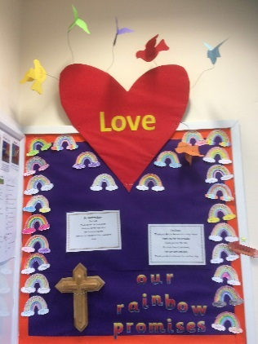

Monitoring the Impact of Collective Worship
Why do we monitor collective worship?

The vision of a church school is that all children and adults are flourishing – does collective worship have an impact on this? How do you know? This is a key focus for monitoring and so questions around this are of paramount importance, as well as questions linked to the essence of your school vision.

What are we doing collective worship for? How do we hope it is having impact? Have we shared this as a rationale statement in our policy for collective worship?

Is collective worship inspirational, invitational and inclusive?

How closely does your school collective worship meet the grade descriptors in strand 6 of the SIAMS schedule?

What questions have come up through your ethos group?

Sometimes the monitoring of collective worship results in only looking at the content, such as the stories, prayer and songs used, whether it was too long or not long enough. These are only important if they have any relevance to the impact on the school community.

The process of monitoring and evaluating collective worship will inevitably result in changes being made. These may be small or major changes. What changes have been made recently due to your monitoring? Quite often these things are happening but informally.

Monitoring will also enable you to recognise some excellence in the quality of collective worship provision. In evaluating this excellence, you may decide that it needs noting that this practice is continued and not lost, that it is shared with others, perhaps across the school, your church or deanery, your MAT, or the diocese. This may then make a difference to others and is worth recording as having a positive impact.

How do we monitor?

How you monitor is based on what your curiosities about collective worship are – there is no one way to do this! In theory it would be possible to reflect after every collective worship and evaluate the impact of the worship on the school community. In the busy life of a school this is almost impossible. In stating this, however, we acknowledge that good leaders and teachers:
- evaluate continuously
- reflect after every teaching and learning event and
- alter their thinking and behaviour in the future.

Who – It is important to get feedback from all groups within your school community, children, staff, parents, governors, ethos group, clergy, visiting leaders of CW, SLT, Trustees / Directors.

Trustees / Directors have a very specific role in terms of the overview across the Trust and ensuring that the specific requirements of the supplemental agreement are being met. Trustees and governors can ensure that the protocols for enhancing high quality collective worship are in place and that all staff appointed understand the nature of collective worship in a church school and have the appropriate training.

How frequently – frequently enough to have impact!
There will be different levels of frequency for each of the groups above. It is invaluable to have an ethos group of some description. There will be questions that come up through these ethos discussions – use them as the next focus for monitoring, eg. how inclusive is our collective worship – you could decide that you will have a class review form for Reception and Y6 or two of your foundation governors will join collective worship several times over the next half term and ask a ‘disengaged’ child how they are finding collective worship - What works well for you? / What would make it even better for you?

I would recommend a strategy or process is put in place for the start of each academic year with details, including provisional dates, for each of these groups of people. Hopefully some of the processes that you already have in place could be utilised for feedback and evaluation. If we are serious about collective worship having an impact, it is more helpful to have short regular bursts of monitoring than to have one long monitoring session infrequently!

What types of monitoring are there – what have you tried that has been informative? Surveys with quantifiable information, feedback and evaluation book, staff discussion with the two key questions, pupil discussion, snowflake specific questions (see links at the end), worship leaders feedback, ethos group progress and impact review, class reflection diaries (although do think about what information you are getting from this – they may give children an opportunity to reflect but be clear about how they inform your evaluation) or a reflection question back in each classroom.

Talking to people is key and happens all the time – see if you can find a way to capture this; perhaps through an ongoing comments book with date, who/role, comment, follow-up/action, or perhaps a summary type overview sheet which can be used in two minutes anytime there is a conversation.
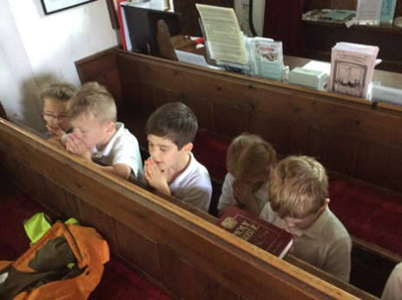
Has your monitoring and evaluation made a difference?

Whatever you use, keep in mind what information it is giving you. Also don’t be afraid to find out what is not working as well as what is working.

One example of some monitoring a school did was through an ethos group discussion where they were talking about the diet of prayer available to the children and wanted to become more creative. They actually realised through their monitoring that the children and staff didn’t really know the Lord’s prayer. They decided to run a term’s theme on this using the Lord’s prayer in various ways. Most children could not only recite it by the end of the term but could talk about it with understanding.

Links to useful collective worship monitoring:
Diocese of St Edmundsbury and Ipswich (Suffolk) – Valuing and Evaluating the Impact of Collective Worship
Diocese of St Edmundsbury and Ipswich (Suffolk) – Tell me about Collective Worship
Diocese of York – Collective Worship
Diocese of Rochester – I particularly recommend the snowflake monitoring activity!
An example of Self Evaluation by Pupils and Staff
Step 1:
Monday - imagine that your school holds whole school worship on a Monday – led by a senior leader in the school (vicar, head, deputy, assistant head etc)
Step2:
Tuesday - there is class worship.
- Class teachers are asked to discuss the previous day’s worship with the class using the 4 simple questions below.
- The class teacher does not have to prepare more material but be prepared to review openly what took place and the impact and influence the worship had.
- The purpose is to discover what the pupils have remembered, understood and learned from the worship.
- If the children did not understand – the class teacher is in an ideal position to develop the ideas at an appropriate level for the class.
- Simply discussing the worship – gives it relevance and importance and for some, a better or deeper understanding.
- The school may use a class liturgy to support this and have a class worship box in which they have a class worship book where any reflections of depth may be recorded by a class worship monitor (KS2 + or recorded by a TA)
Step 3:
The class teacher now has information that can be shared verbally (and may have written evidence from the class worship book) with the leadership at the next staff meeting. It should only take a few minutes to gather feedback from the classes.

Consequences
The children will soon realise that the school is interested in their views on worship and that worship and their views matter.
After a couple of weeks, they may well be taking more note of the Monday worship – they know it will be discussed the next day.
The school is giving voice to the pupils. It is also providing them with a vocabulary and language to discuss worship.
Over time the school will be more informed about what works – has impact and influence.
The pupils and staff will better understand what the purpose of worship is and can become.
The pupils and staff will be more confident to prepare and lead worship for a class or school.
Worship will develop in the school through pupil voice and be a demonstrable aspect of the school that is both Christian and distinctive.

Using a Worship Council/ School Council to evaluate worship
The 4 simple questions to ask pupils.
- Tell me one thing you liked about the Collective Worship you have just been in? - This is a personal idea just about your feelings or thoughts.
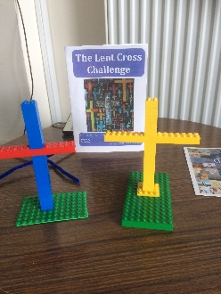
- Tell me one thing that would have made it better for you? - This is a personal idea just about your feelings or thoughts.
  - Tell me what it was about? - This is about factual recall.
- Tell me why did the person leading the worship do what they did? (How you phrase this depends on the age of the pupils): -
  - So what was it about?
  - What do you take away?
  - What do we learn about how we live our lives?

Further thoughts
If the only purpose of evaluation is to provide an audit trail for inspection, then the rationale is flawed – if it is to improve practice then here are some thoughts other than a daily record that could be more effective.
- Invite another adult (Vicar, governor, learning support, parent) to talk to pupils of all ages about how Collective Worship feels for them. Record the outcome of these conversations and review them with staff who lead Collective Worship, Leadership Team, the vicar or governors.
    - Set aside 15 minutes of a staff meeting once a term to review how staff feel about Collective Worship. Record the outcome of these discussions and review them with staff who lead Collective Worship, Leadership Team, the vicar or governors.
- Add a question on the parent and or the pupil questionnaires about perceptions of Collective Worship.
- Use a Collective Worship folder to keep all planning in and check that there has been an evaluative comment at the end of each day / week.
- Invite the vicar or diocesan officer to observe a Collective Worship and spend quality time afterwards to discuss the various aspects of the worship.
- Invite a diocesan officer to review the overall planning of worship.
- Video a Collective Worship and watch and reflect on it yourself. You could place the camera on the floor pointing upwards, so it captures a child’s eye view.
- Plan in termly church school partnership meetings in which the previous termly theme is evaluated, and the new theme planned. Make notes as a record of your evaluative comments.
- Enable informal evaluation through capturing children and adults’ thoughts on reflection trees / collective worship displays, etc.
- Prayer spaces can be used as a capturing of children’s responses to worship. Any prayers could be valued by being read in the Sunday service by the vicar or at the celebration service each week.
- Impromptu evaluations occur through discussions with children; about their behaviour in worship, follow-up in curriculum time or conversations in the playground. Any gems can be captured and put in the collective worship file.

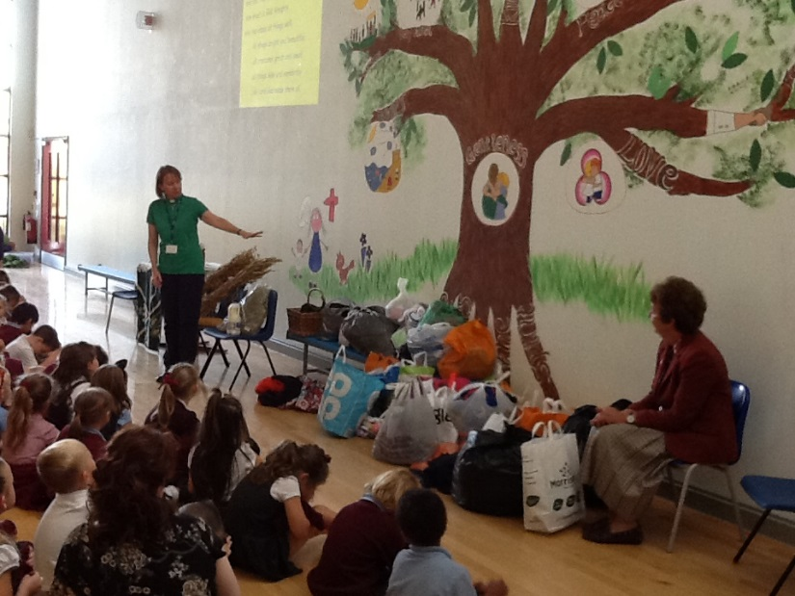

Monitoring Focus:
Date:
Staff / Governors / Clergy / Others involved:
Strengths: | Impact:
Areas for Development: | When | Who
Other comments:

Children Evaluating the Impact of Collective Worship
This Photo by Unknown Author is licensed under CC BY-NC-ND

Children’s names:
Date:
Theme:

Our School Vision:
Have you seen or heard about how this collective worship has made a difference to your school vision?

How did collective worship being inspirational make a difference? | How did collective worship being invitational make a difference? | How did collective worship being inclusive make a difference?
Do you think this collective worship helped children or adults to flourish (feel really good about themselves and life)?

How do you know?

Are there any other ways you know about where this collective worship has made a difference to someone?

Collective Worship Monitoring

Name of Leader: Theme: Date:
Criteria | Aspect | Comment
Gathering together | Is there a real sense of a marking the start of a very special time in the school day?  Immediate impact, relevant welcoming, stimulates interest or dull, uninteresting, lacks focus
Engaging together | Does the worship leader capture the attention of the children and the staff so they become actively engaged in the content?  Excellent – well expressed, stimulating or poor communicator  Convincing, enthusiastic, warm or lack of rapport
Responding together | Does the leader allow for a response from the children and adults – whether active, passive, noisy or quiet?
Leaving together | Does the leader send us out with a clear ‘thought’ or ‘action’ for the day something that changes our behaviour in some way?

Collective Worship Record
Date & time
Observer
Present: whole school/key stage/class
Collective worship led by
Theme

Gathering together
How did the pupils enter the room – was there a sense that this was going to be a special time together?
Was there anything to mark the worship space and time as special e.g. a visual focus, (e.g. candle, worship table, display)?
How was the theme communicated to those gathered?

Engaging together
What elements were used to explore the theme?
- Visual elements
- Listening elements
Who helped lead?

Responding together
Spoken responses – prayer/ collective prayer / song

Silent responses – reflection time / observing dance/drama/music/mime

Action responses – receiving/giving something / drawing / placing something on a display

Leaving together
Final prayer/blessing

Final thought – practical application for children to take into the day

General consideration
Did the leader hold all the children’s and adult’s attention?
Did the leader make appropriate use of his/her voice?

Children’s & Adults’ Comments/Observations – (What was enjoyable/special/made me think/helped me?)
Key consideration:
Was it distinctively Christian in content? (none / little / mainly / wholly)
What was the impact on pupils – how well did they engage? (little / some / good / very good)

Did any elements contribute to children’s spiritual and/or moral development?

Collective Worship in Church Schools – Self-evaluation

Aspect | Already a strength/evidence available | We could improve this by | The biggest barriers to improvement are
Is given a high priority

Meets legal requirements

Is valued as an important community event and enjoyed

Is held within a helpful environment

Has a budget for resources

Has a written policy, agreed by governors

Staff receive in-service training

Is jointly planned by leaders

Children plan, lead and evaluate collective worship

Clergy contributes and members of the parish are involved
Parents are invited when appropriate

Has a Christian character

Provides a positive experience of Christianity

Contributes to spiritual, moral, social, cultural development

Is monitored by staff, governors, trustees.

