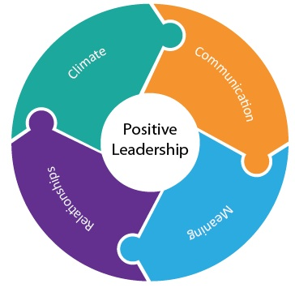

Module / Theme : Relationships
Activity : Reflections on Leadership ( reading a text together and discussion )
Purpose :
This activity is designed to give each partner within the relationship a tool to think about leadership differently and from a Christian perspective. A choice of texts provide a starting point and are intended to provide a tool for reflection and a tool for discussion.
Resources :
- Stephen Cottrell ‘Hit the ground Kneeling – seeing leadership differently’
- Grove Education booklets ‘Head Teachers as Community Pastors’ & ‘Sustaining Hope in School Leadership’
How to use this activity
- Either allocate a 15 minute slot in one of your regular meetings to read and discuss a chapter together, or commit to taking time out of school and parish to do the same. Come together with your thoughts and comments.
- Reflect upon and share how the book /s speak to you both in your personal leadership journeys and what each of you brings to the relationship in terms of strengths and needs in your leadership.
- Think about how you might develop a joint approach to leading your community together.

