# Annual Review and Self Evaluation of Reader Ministry, 2024

From:

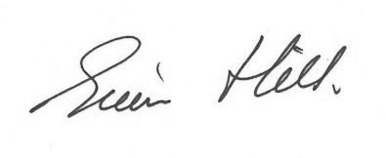

Diocesan Warden of Readers

Martin Ann

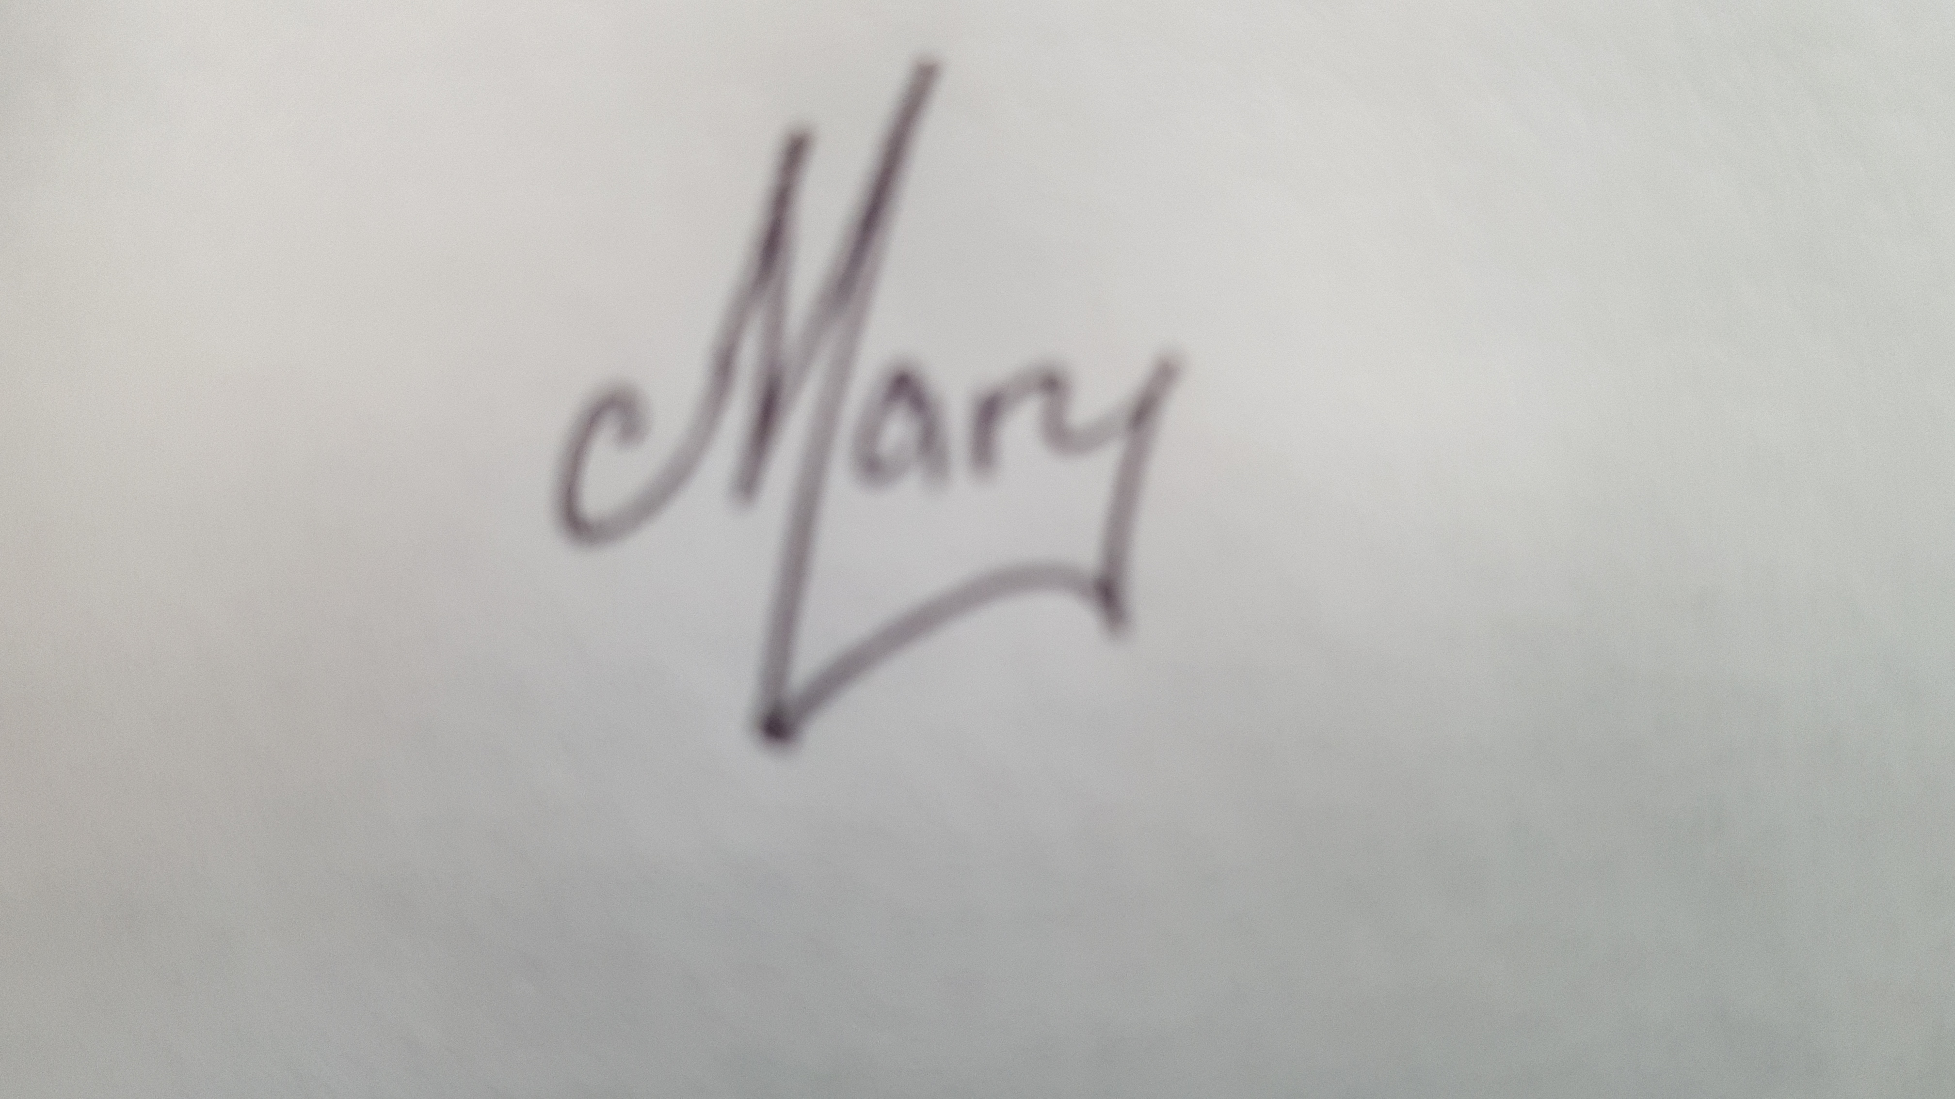

Archdeaconry and Assistant Archdeaconry Wardens of Readers

For many years now, the Bishops and Archdeacons, not to mention Readers’ Council, continue to be amazed by all that the Reader community does, and continues to do, both as Readers, and in other facets of church life. The Diocese, and indeed the national church, continues to face challenges, which will undoubtedly cause changes in the way we all work in the not-too-distant future, as shared local ministry develops. Change inevitably brings uncertainty, but we know that, with God’s guidance and support, the Readers in Bath & Wells will again rise to the occasion, fulfilling their roles as Teachers of Faith, as Enablers of Mission and as Leaders in Church and Society.

And how active were Readers in 2024? Well, it’s Annual Review time, so we shall soon find out!

This Annual Self-Evaluation process is not intended to add to the burden of your faith and witness – rather we hope it will act as a tool for self-reflection, on how you and your vocation as a Reader has been affected by the situation you find yourself in. You know the power of story telling in the Bible and we hope this form will encourage you to reflect on your own story and faith in the communities where you live and serve.

To that end, you may either complete the self-evaluation form as it stands and using the framework of questions offered (Page 5)

**OR**

You may choose to write of your own stories, laments, unexpected joys and surprises of ministering during 2024, without the possible constraints of fixed questions.

The choice is yours!

We’re confident that we will find encouragement in the answers you submit and promise to respond with ‘prayer and thanksgiving’ for your work and witness. Whether you complete the questionnaire as attached, or reply in ‘free form’, you are asked to review your return with your Incumbent or, if you are in vacancy, with your Area Dean.

The following timescales are envisaged:

* No later than **28 February 2025**, can you please have your completed returns returned to your Archdeaconry Warden (as below). This should, preferably, be with your Incumbent’s comments, but if you cannot review them with your Incumbent, then please return them without. While doing so by email is preferable, by post is, of course, perfectly acceptable.
* Also no later than **28 February 2025** can you please ensure that your Statistical Questionnaire is completed, preferably online but, if necessary, on paper in which case they should also be returned to your Archdeaconry Warden (as below).
* No later than **31 March 2025**, we hope to have all the statistical data processed ready for analysis.
* We remain committed to doing all we can to comment on ALL returns received, both to ensure that we can respond to any concerns you may have, but also to address any themes which may be developing. It is our intention, God willing, to have all replies sent back to Readers, from either the Archdeaconry Warden or the Assistant Archdeaconry Warden, within a month of receipt; please note that these replies to you may be by either email or in writing.
* Allowing for Lent and Easter (which in 2025 is 20 April), we then aim to have all the statistical analyses completed and a report / article on the 2024 Reader contribution no later than **30 April**, hopefully sooner.

**The Annual Self-Evaluation Questionnaire** (which follows) is created to assist you to reflect on and analyse the past year. There are eight questions to consider, and you are invited to use them to reflect on your ministry. You may find it helpful to spend some time praying and thinking about the questions first. Please feel free to use it as a tool by which to consider how your own ministry is exercised. You might also like to consider your ministry in the wider context of -

1. The commission at your licensing.

"My brothers and sisters, Christ has called us into the fellowship of the universal Church and, according to our gifts, to be agents of his mission in the world. Readers are called to the ministry of the Word: to bring God into the conversation, to lead people to Christ that they may become his disciples, and to equip them to share the good news of God’s kingdom. They lead worship, teach and preach, building up the Church, and working with others to make Christ visible. When you were admitted as a Reader you undertook to be faithful in prayer and, by word and example, to serve those for whom Christ died. I invite you now to dedicate yourselves afresh to his service, as heralds of his gospel and ministers of his grace."

1. Your current ministry specification – if you do not have one, now is a good opportunity to put one in place!
2. How your ministry is exercised in terms of the three areas identified in the recent CRC Report on Reader Ministry. The three areas are

* Readers as enablers of mission
* Readers as teachers of the faith
* Readers as leaders in church and society.

1. The Diocesan vision and priorities for mission and evangelism

The vision in the Diocese is:

* In response to God’s immense love for us we seek to be God’s people living and telling the story of Jesus.

The three priorities are:

* To place mission and evangelism at the heart of all we do
* To align our ministry resources towards mission
* To identify, develop and use the gifts of all our people

When completed, please return to your Archdeaconry Warden or Assistant Archdeaconry Warden, as below, by **28 February 2025** at the latest.

|  |  |
| --- | --- |
| **Bath Archdeaconry** |  |
| * Returns for Readers in the Bath, Chew Magna and Midsomer Norton Deaneries should be sent to Mary Dolman. | Mary Dolman, Reader Archdeaconry Warden 14 Upper Furlong Timsbury Bath BA2 0NN 01761 472635 [mary.dolman@bathwells.anglican.org](mailto:mary.dolman@bathwells.anglican.org) |
| * Returns for Readers in the Locking and Portishead Deaneries should be sent to Simon Stevens. | Simon Stevens, Reader Asst. Archdeaconry Warden 115 Hillside Road Portishead BS20 8LF 01275 848487 [simon.stevens@bathwells.anglican.org](mailto:simon.stevens@bathwells.anglican.org) |
| **Taunton Archdeaconry** |  |
| * Returns for Readers in the Exmoor, Somerset South and Tone Deaneries should be sent to Martin Valuks. | Martin Valuks, Reader Archdeaconry Warden  Culverhead Lodge  Wiveliscombe  Taunton  TA4 2TA 01984 623302  [martin.valuks@bathwells.anglican.org](mailto:martin.valuks@bathwells.anglican.org) |
| * Returns for Readers in the Quantock, Sedgemoor and Taunton Deaneries should be sent to Ann Philcox. | Ann Philcox, Reader Asst. Archdeaconry Warden  Minack  42a Monmouth Road  Westonzoyland  TA7 0HG 01278 691438  [ann.philcox@bathwells.anglican.org](mailto:ann.philcox@bathwells.anglican.org) |
| **Wells Archdeaconry** |  |
| * Returns for Readers in the Axbridge, Glastonbury, Ivelchester and Yeovil Deaneries should be sent to Chris Stock. | Chris Stock, Reader Archdeaconry Warden Charnwood Duckpool Lane West Chinnock  TA18 7QD 07768 790145 [chris.stock@bathwells.anglican.org](mailto:chris.stock@bathwells.anglican.org) |

|  |  |
| --- | --- |
| * Returns for Readers in the Bruton & Cary, Frome and Shepton Mallet Deaneries should be sent to Sue Kellagher. | Sue Kellagher, Reader  Asst. Archdeaconry Warden Ashcombe House Hallett Road Castle Cary. BA7 7LG 07780 991938 [sue.kellagher@bathwells.anglican.org](mailto:sue.kellagher@bathwells.anglican.org) |

We have deliberately kept the **Statistical Questionnaire** (which is in a separate document) as similar to last year’s as possible; this will allow much better trend analysis from one year to the next. Please do take time to complete this as it will be a real testimony to the enduring providence of God, and the enormity of activities being undertaken by Readers.

Please complete the Statistical Questionnaire, preferably online at <https://forms.office.com/e/gNssSMvvg3>

but if necessary on paper; if completed on paper, then please return it to your Archdeaconry Warden, as below, by **28 February 2025** at the latest.

# Annual Review and Self Evaluation of Reader Ministry for:

**Reader Name: …………………………………**

**Benefice: …………………………………**

**Deanery: …………………………………**

## Questions to assist your reflection.

(Use these as helpful, either with individual answers or an overall answer on another sheet)

1. What has been fulfilling and important in your ministry in the past year? Please give examples.
2. Are there areas of ministry that have not been as rewarding as you hoped? Can you identify why this might be so?
3. Are there any areas of ministry that you feel you would like to change in the next year – this might be new work, taking on a new role or setting down some aspect of ministry? Please identify any changes you would like to make. How might this affect your Ministry Specification?
4. Do you feel supported in your ministry? Whom do you identify as offering that support? Would you like the support of a peer review?
5. List any issues that you would wish to raise from this self - assessment review with your Archdeaconry Warden or Assistant Archdeaconry Warden of Readers (including any request for a peer review)?

## Ministerial Development (Please note that this page may be shared with the Diocesan Ministry Training Team, anonymously, to assist them with developing the CMD programme.)

1. Please record how you have continued your own spiritual and ministerial development over this last year (e.g. courses attended, spiritual direction received, study or reading undertaken, significant books, reflective practice, retreats etc.)
2. What areas of personal, spiritual and ministerial development, including training, do you need in this next year? How will you arrange it? Is there help you need?

Signature of Reader: **…………………………………** Date: **………………………**

Please return your Self Evaluation Review to the Archdeaconry Warden, or Assistant Archdeaconry Warden by **28February 2025** at the latest.

**Incumbent’s Thoughts and Observations**

We invite your incumbent to use this space to provide some thought on how your ministry is received and welcomed in the Parish / Benefice, how it’s developed and if appropriate what you have jointly identified as continuing ministry or new ministry that you will be considering over the next year.

I confirm that (N) ………………………………………………………….. and I have met together to review his / her ministry.

Signed ……………………………………………… Incumbent (or Area Dean in the absence of an Incumbent)

I confirm that this Return has been discussed with my Incumbent (or Area Dean)

Signed …………………………………………….. Reader

Do you have a Ministry Specification? **Yes / No**  (Please delete accordingly)