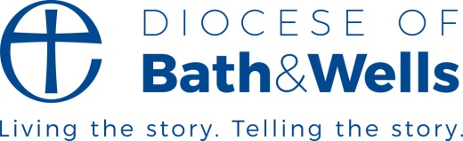

Bishop’s letter

I’m new around here. Following retirement from ordained ministry last year Somerset has become my adopted county and Bath and Wells my adopted diocese. Sally and I are delighted to be full time now in this lovely and stimulating area. We join many of you who have been part of this diocese and county for a lifetime or for decades, and also some who have recently arrived like us.
We have chosen to be here. Others arrive here because of a range of circumstances and decisions. Perhaps sometimes the journey seems haphazard or inexplicable. Some people come here as refugees fleeing persecution, injustice, or war, especially from Syria, Afghanistan, and Ukraine. They arrive with uncertainty, and often anxiety or trepidation in an unknown and entirely new place far from home.
In our churches and Christian communities, we are committed to welcome everyone – those settled here and also those who are newer. We know we are sisters and brothers in God’s family, regardless of background, nationality or indeed any other thing which distinguishes us. God’s family is the family of humankind. It’s not that we pick and choose whom to call family; we share the same flesh and blood.
St Paul tells us that each one of us has been adopted into that family which is divine and human. God sent Jesus “so that we might receive adoption as children” enabling us to be gifted with the Holy Spirit. (Galatians 4:4-7)
We don’t belong out of personal choice, in contrast to my decision to choose here as my adopted diocese and community. We don’t pick and choose our ultimate citizenship. God chooses and calls us without us desiring or deserving such adoption. That’s why, following God’s adoption of us, we never select who to welcome into our church or parish. All belong and all are welcome without hesitation.
We have been adopted into God’s family and we are thrilled to adopt everyone into our communities. Thank you for welcoming me!

+Christopher Foster (Honorary Assistant Bishop Bath and Wells)

