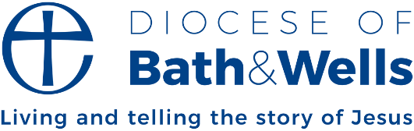

Bishop’s letter – ‘Jesus, the Light of the World’

‘All is calm, all is bright’ may not be the words that many of us would use to describe our experience of either the run up to Christmas or the feast itself. Presents to buy and wrap, food to order and cook, events and church services to be part of. And that’s before we’ve negotiated the big day itself. I saw one website recently that claimed that Christmas is considered as one of the six most stressful life events, along with divorce, moving house and changing jobs!
In the midst of such chaos, our churches offer an opportunity to find peace during this busy time – of stillness, quiet and the opportunity to stand back from all the pressures that the season contains. This year, the Church of England's theme for Advent and Christmas is Follow the Star: Calm and Bright. The theme draws on some of the lyrics of the famous carol, Silent Night:
“Silent Night! Holy Night!
All is calm, all is bright...”
To be calm and bright is to be invited into the still centre of the Christmas story. It’s to contemplate Mary holding the new-born Jesus, the Light of the World. It’s to open ourselves to the joy of the angels as they tell the shepherds “Do not be afraid - Fear not!” It’s to encounter the wonder of the wise men as they discover that the gift of this child is for the whole world.
May your Christmas 2024 be ‘Calm and Bright’!

Bishop Michael Beasley
Bishop of Bath and Wells

