The Commissioning and Appointment of
Christopher Jones
as Joint Diocesan Registrar
in the Diocese of Bath & Wells

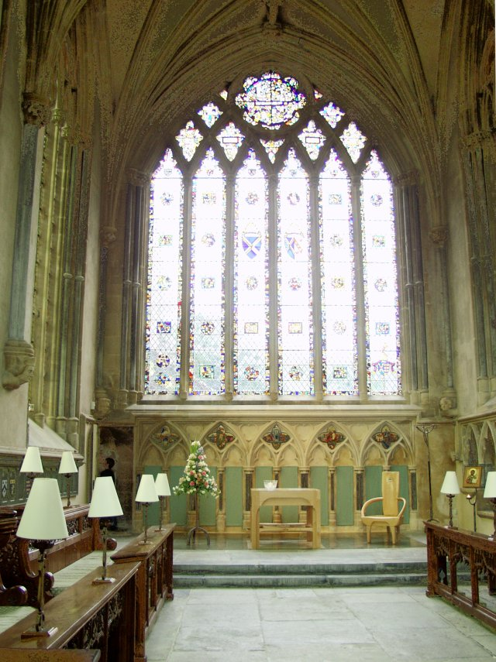

Wednesday 23rd June 2021
at 4pm

Bishop Ruth introduces the service

Reading:
Let love be genuine; hate what is evil, hold fast to what is good; love one another with mutual affection; outdo one another in showing honour. Do not lag in zeal, be ardent in spirit, serve the Lord. Rejoice in hope, be patient in suffering, persevere in prayer. Contribute to the needs of the saints; extend hospitality to strangers.

Bless those who persecute you; bless and do not curse them. Rejoice with those who rejoice, weep with those who weep. Live in harmony with one another; do not be haughty but associate with the lowly; do not claim to be wiser than you are. Do not repay anyone evil for evil but take thought for what is noble in the sight of all. If it is possible, so far as it depends on you, live peaceably with all. Beloved, never avenge yourselves, but leave room for the wrath of God; for it is written, ‘Vengeance is mine, I will repay, says the Lord.’ No, ‘if your enemies are hungry, feed them; if they are thirsty, give them something to drink; for by doing this you will heap burning coals on their heads.’ Do not be overcome by evil but overcome evil with good.

Romans 12. 9-end

Bishop Ruth offers a short reflection on the reading

The Commissioning

Chris and Roland stand before the Bishop at the steps of the chapel. Chris is presented to Bishop Ruth by Preb Roland Callaby.

Roland: Bishop I present to you Christopher David Jones to be joint registrar in this diocese.

Bishop Ruth prays:

God our Father, Lord of all the world,
through your Son you have called us into the fellowship
of your universal Church:
hear our prayer for all your faithful people
that in their vocation and ministry
each may be an instrument of your love,
and give to your servant, Chris
the needful gifts of grace;
through our Lord and Saviour Jesus Christ,
who is alive and reigns with you,
in the unity of the Spirit,
one God now and for ever.
Amen.

Bishop Chris, you have been chosen as Joint Registrar in this diocese.
Do you believe that God has truly called you to this ministry?

Chris I believe that God has called me, and, with his help, I will
serve faithfully in this ministry.

Bishop Heavenly Father, we gather in your name with thankfulness and praise for all who have been envisioned afresh in times past to serve you in this Diocese and for your servant Chris, now called by you to these present tasks. Guide and strengthen all your faithful people that we may give ourselves in love and service to one another and to your world with renewed vision and service; through Jesus Christ our Lord.
All Amen

The Bishops’ Chaplain prays for Chris in his work and the work of all the Registry staff.

Bishop Ruth prays,

Bishop Almighty Father, give to your servant Chris, grace and power to fulfil this new ministry: to watch over and care for those they work amongst and to proclaim the gospel of salvation. Set him among your people to offer with them spiritual sacrifices acceptable in your sight and to minister the sacraments of the New Covenant. As you have called him to your service, make him worthy of your calling. Give him wisdom and discipline to work faithfully with his fellow servants in Christ, that the world may come to know your glory and your love. Accept our prayers, most merciful Father, through your Son Jesus Christ our Lord, to whom with you and the Holy Spirit belong glory and honour, worship and praise, now and for ever.

The Appointment
The Bishop calls upon Chris to swear allegiance to the Queen, to work with integrity and to affirm his loyalty to the Anglican inheritance of faith.

Christopher, the Church of England is part of the one, holy, catholic and apostolic Church, worshipping the one true God, Father, Son and Holy Spirit. It professes the faith uniquely revealed in the Holy Scriptures and set forth in the catholic creeds, which faith the Church is called upon to proclaim afresh in each generation.
Led by the Holy Spirit, it has borne witness to Christian truth in its historic formularies, the Thirty-nine Articles of Religion, the Book of Common Prayer, and the Ordering of Bishops, Priests and Deacons.
Will you now swear your allegiance to the sovereign, undertake your duties with integrity and declare your beliefs in the faith we share?
Chris responds

I CHRISTOPHER DAVID JONES do swear that I will be faithful and bear true allegiance to Her Majesty Queen Elizabeth II her heirs and successors according to law: So help me God

I CHRISTOPHER DAVID JONES do swear that I will to the uttermost of my understanding deal uprightly and justly in my office without respect of favour or reward: So help me God

I CHRISTOPHER DAVID JONES declare my belief in the faith which is revealed in the Holy Scriptures and set forth in the catholic creeds and to which the historic formularies of the Church of England bear witness

The Bishop reads the deed of appointment. The assembled people then say together:

All Chris, we welcome you!

May the Lord make you a blessing

among those to whom you minister,

and may we be a blessing to you,
as we work together for Christ.

Recognising that Roland will be retiring on 30th June, Bishop Ruth thanks him for his faithful service. The Bishops’ Chaplain then prays for him as he enters this new phase of life and ministry.

The bishop blesses Roland and Chris and all who are gathered.

God the Holy Trinity
make you strong in faith and love,
defend you on every side
and guide you in truth and peace;
and the blessing of God almighty,
the Father, the Son and the Holy Spirit,
be upon you and remain with you always.
All Amen.

We show our encouragement and appreciation for Chris, Roland and all
the Registry staff

The Chapel of The Holy Trinity and St Mark

