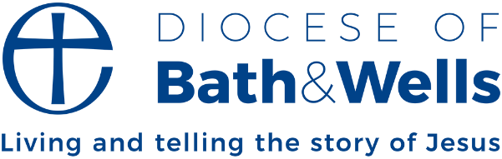

Dean’s letter
By Toby Wright, Dean of Wells

Someone once asked the great Anglican monastic theologian Herbert Kelly this question: ‘How do we know what the will of God is?’ to which he famously answered, ‘We don’t. That’s the joke.’
Kelly is right: we can’t know precisely what God’s will is in a certain situation. But we can open up opportunities for God to ‘come through’ our actions, and building community is a key way of doing this. In any situation we can try and tune our lives a bit more to God. And across our diocese our commitment to our communities is key to this.

So, when we meet people, a simple smile shows the person before us we see them as a friend. This is not to suggest ignorance or naivety. We are not unaware of the limitations and imperfections of a person, but we are prepared to focus more deeply, to the depths of the heart in each person. To seek out the goodness that only love and trust can bring to birth.

As a Cistercian writer recently put it: ‘Let us welcome each person as Christ, because in all truth it is Christ whom we welcome. ‘You did this to me’ (Matthew 25). Let us look for the beloved face of Christ in each person, for each is his true face.’

But why start our focus on community, with those around us, and not God? Good question. Perhaps it is best explained by a lovely saying from the Desert Father, John the Dwarf: ‘You don’t build a house by starting with the roof and working down. You start with the foundation.’
They said, ‘What does that mean?’
He said, ‘The foundation is our neighbour whom we must win. The neighbour is where we start. Every commandment of Christ depends on this.’

Toby Wright
Dean of Wells

