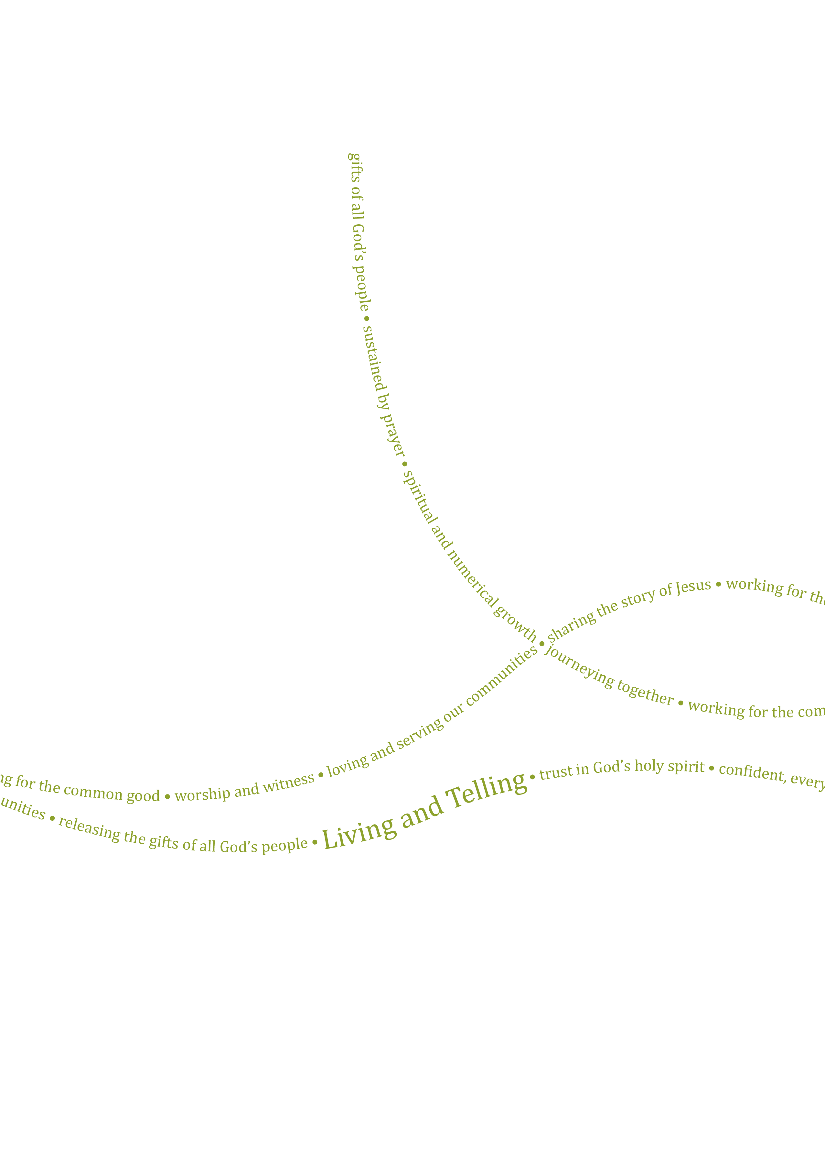

**Application Pack Aug 2022**

**Property Assistant**



**Application Pack April 2022**

**Growing Faith Adviser (Fixed Term)**

Contents

Recruitment Timeline 3

The Diocese of Bath and Wells 4

More Information 5

Job Description 7

Person Specification 9

Main Terms and Conditions 12

Contact details

**Human Resources**

Enita Andrews

Ph: 01749 685 113

Email: [recruitment@bathwells.anglican.org](mailto:recruitment@bathwells.anglican.org)

For an information discussion about the role, please contact:

**Tony Cook**

**Head of Growing Faith and Everyday Faith and Go Team Leader**

Email: [tony.cook@bathwells.anglican.org](mailto:tony.cook@bathwells.anglican.org)

Ph: 07922576757

Dear Applicant

Thank you for your interest in the post of Growing Faith Adviser with Digital Media. This post sits within the Diocesan Board of Education (DBE), employed by the Bath & Wells Diocesan Board of Finance (DBF). I am delighted to let you have details about the diocese and information about the post.

We hope you find the application pack provides all the information you need in order to consider your candidature for this post. If, however, you have any further questions please initially contact Human Resources.

Meanwhile, please find opposite, key dates for the appointment process. Should you decide to apply for this post we look forward to receiving your application and wish you well.

Kind Regards

Enita Andrews

**HR Manager**

**Applications**

Applications must be received by **midday Thursday 22 September 2022**. Application forms, with a covering letter no more than one side of A4describing what attracts you to this role should be returned to Human Resources either by post to The Diocesan Office, Flourish House, Wells, BA5 1FD or by email to [recruitment@bathwells.anglican.org](mailto:recruitment@bathwells.anglican.org).

**Shortlisting**

To ensure the fairness of the selection process, shortlisting will be based upon the information which you provide in your application and assumptions will not be made about your experience or skills. We will look for demonstrable evidence that you meet the criteria set out in the person specification. A copy of our privacy policy for job applicants can be downloaded from our website.

**Interview**

Interviews will take place in Wells on **Monday 3October 2022**. Further details regarding the selection process will be communicated at the time applicants are invited for interview.

**Safeguarding**

We are committed to the safeguarding and protection of all children, young people and adults, and the care and nurture of children within our church communities. We will carefully select, train and support all those with any responsibility within the Church, in line with Safer Recruitment principles. This means that we will:

* Ensure that our recruitment and selection processes are inclusive, fair, consistent and transparent.
* Take all reasonable steps to prevent those who might harm children or adults from taking up, in our churches, positions of respect, responsibility or authority where they are trusted by others.
* Adhere to safer recruitment legislation, guidance and standards.

Further information can be found in our Safeguarding Policy available on the diocesan website. All applicants are required to complete a Confidential Declaration Form as part of our recruitment process when an offer of employment is made. This form is strictly confidential and, except under compulsion of law, will be seen only by those involved in the recruitment/appointment process and, when appropriate, the nominated safeguarding lead or someone acting in a similar role/position. All forms will be kept securely in compliance with the General Data Protection Regulation, 2018.



**The Diocese of Bath and Wells**

The Diocese of Bath and Wells is one of 41 Church of England dioceses in the country. The diocese stretches from Portishead in the north to Crewkerne in the south, Minehead in the west to Frome in the east.

The diocese loves and serves the 940,000 people who live here through its family of 466 parishes and 181 church schools. This family works for the good of local communities in a range of practical as well as pastoral ways: caring for the vulnerable in our societies, supporting local families and encouraging children and young people.

Everything the diocese does is underpinned by prayer and worship and is driven by our vision:

“In response to God’s immense love for us, we seek to be God’s people, living and telling the story of Jesus.”

If successful in your application, you will be arriving in the diocese at a time of significant change and you will have a role to play in the diocesan strategy, which has these three strategic priorities:

* To place mission and evangelism at the heart of all we do.
* To re-align our ministry resources towards mission.
* To identify, develop, and release the gifts of all our people.

**The Education Department**

The Education Department serves all ages across the diocese of Bath and Wells, leading and supporting work with children, young people and adults, connecting education settings, parishes and households.

The Education Departments four aims are underpinned by John 10 v10.  Where Jesus said, I have come that all may have fullness of life.

1. All church schools are inclusive, sustainable, providing highest quality education for all pupils and enabling individuals and whole communities to flourish.
2. All church schools will actively be part of strong Trusts with appropriate church articles and consistent, strong support for the deeply Christian foundation of church schools.
3. Church schools, parishes and households are encouraged to work together in creating and accessing clear pathways to explore and grow in Christian faith.
4. Children and adults are empowered and equipped to live out the fullness of the Christian faith and values in everyday life.

The Education Department is governed and held to account by the DBE and consists of three teams (School Effectiveness, School Organisation and the Go Team). All three teams have shared responsibility for achieving the Department’s aims and are part of wider DBF staff teams working closely in each archdeaconry.

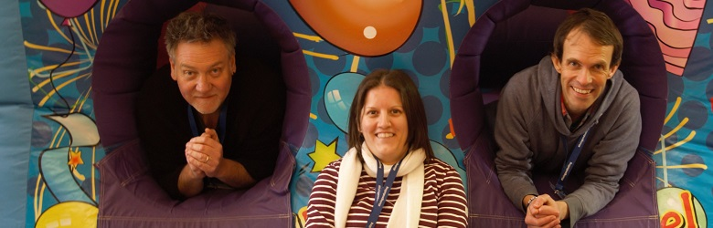

**The Go Team**

The Go Team is responsible for two key elements of the diocesan strategy ‘Growing Faith’, making the most of the connections and intersections between church, household, and school, and ‘Everyday Faith’, enabling everyone, of any age to explore, grow and share faith in everyday ways.

The Go Team aims to **S**upport, **E**ncourage, **R**esource, **V**alue and **E**quip all those working with young people, children and families, and all involved in adult discipleship. This includes paid workers and volunteers, trainee students, school chaplains, teachers, clergy, readers, small group leaders and others.

* **Support:** Providing high quality support and advice
* **Encourage:** Encouraging parishes and deaneries in what they are doing, and in new approaches that lead to culture change
* **Resource:**Providing and signposting to relevant resources and events to enable mission
* **Value:** Building and maintaining relationships with key people to enable ministry
* **Equip:** Providing and signposting to appropriate training opportunities.

This exciting post has come about due to one of the current Go Team members being seconded to the new National Growing Faith Foundation for a fixed term. Rather than backfilling with a like-for-like post we wanted to be creative and combine the role of an adviser in the Wells archdeaconry with helping the Go Team and Education Department to further developing our digital and social media. This could be an exciting opportunity for a current and experienced parish youth or children and families worker to step into and grow into an advisory role as part of their professional development.

**Education Department Structure**

Andy Levett

Growing Faith & Everyday Faith Adviser (Go Team)

Cheryl Govier

Growing Faith & Everyday Faith Adviser (Go Team)

Tony Cook

Head of Growing Faith & Everyday Faith (Go Team)

Andy Gray

Faith Sharing Enabler

(Go Team)

Felicity Cobley

Education Administrator

(School Effectiveness and Go Team)

Ed Gregory

Director of Education

Josie Halla

Education Administrator

(School Organisation)

Louise Jenkins

School Organisation Adviser

Suzanne McDonald

School Organisation Lead & Adviser (Assistant Director)

Claire Hudson

School Organisation Adviser

Pauline Dodds

School Effectiveness Adviser

Karen Sancto

School Effectiveness Adviser

David Williams

School Organisation Lead & Adviser (Assistant Director)

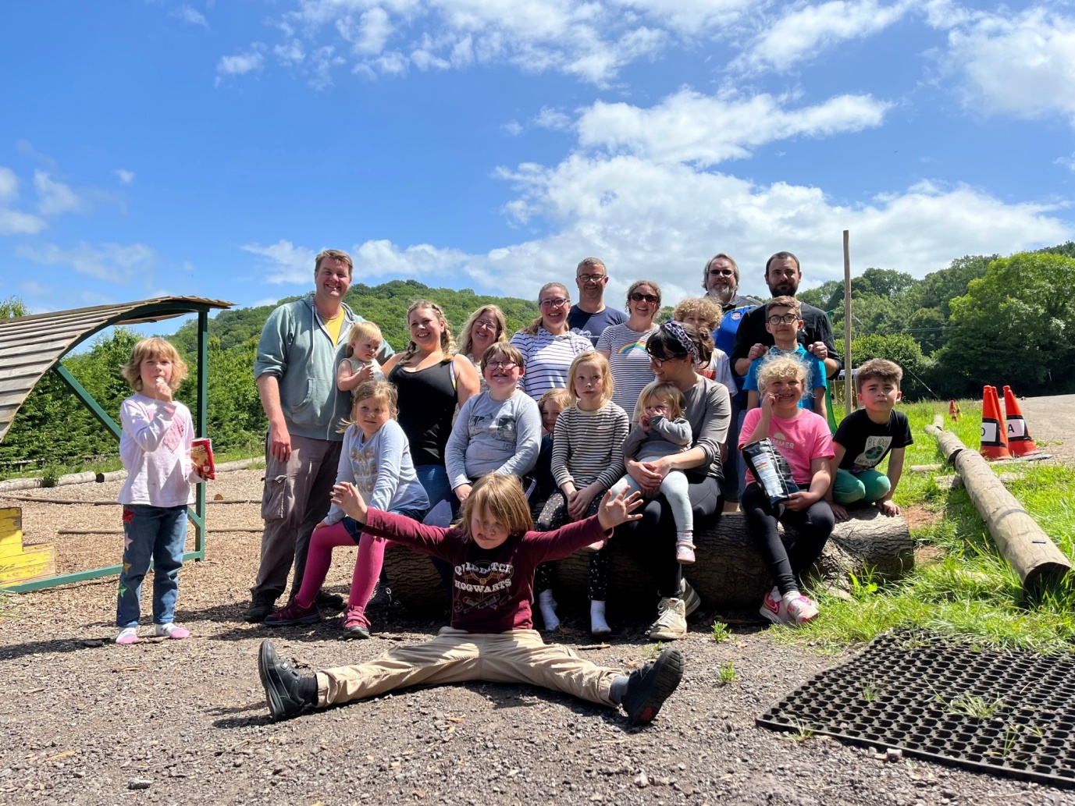



**Job Description**

|  |
| --- |
| **POST: Growing Faith Adviser with Digital Media Coordination (Fixed Term for 3 years subject to review)** |

|  |
| --- |
| **Our vision**  In response to God’s immense love for us, we seek to be God’s people living and telling the story of Jesus. |

|  |
| --- |
| **Key purpose of the post:**  This is a backfill for a secondment by the Growing Faith & Everyday Faith Adviser for the Wells Archdeaconry   * As one of the team of Growing Faith & Everyday Faith advisers, to be an enthusiastic advocate of Growing Faith and Everyday Faith, inspiring and encouraging people to live out the Christian faith in day-to-day life. * To offer dedicated support to the archdeacon, deaneries, and parishes of the (Wells) archdeaconry in developing faith in children, young people, and adults. * Ensure the work of the Growing Faith & Everyday Faith advisers, and others is communicated across social media and other digital platforms. |

|  |
| --- |
| **Location:** Archdeaconry-based/flexible - Flourish House when required |

|  |
| --- |
| **Reporting to:**  Head of Growing Faith and Everyday Faith |

|  |
| --- |
| **Hours of work:**  Part Time (20 hours per week) |

|  |
| --- |
| **Key relationships:**  Diocesan Education Department staff  Colleagues across diocesan support services  The Communication Team  DBE, including the Faith Development Committee  Diocesan Safeguarding Team  The Archdeacon (of Wells)  Area Deans & Lay Deans (in the Wells archdeaconry)  Other Christian organisations resourcing and supporting Christian ministry and discipleship |

|  |
| --- |
| **Main Responsibilities**.  **Growing Faith and Everyday Faith (Shared with the GF/EF advisers)**   * Work together, as a team and with colleagues across the diocese, to share a passion and vision for Growing Faith and Everyday Faith. * Support, encourage, resource, value and equip churches in opportunities for faith development, that is age appropriate and promotes sustainability, inclusion and diversity. * Encourage all parishes, benefices and deaneries to work together with their schools and households in accessing clear pathways to explore and grow in Christian faith. * Signpost to and encourage churches to access resources for discipleship and mission across all generations. * Work with colleagues in Education and across the areas of Mission Support and Ministry Development in providing training that fulfils the diocesan strategy. * Work with the GF/EF advisers in organising and delivering a range of events. * Ensuring the voices of children / young people influence and shape the work of the Education Department.   **Social Media**   * Develop and maintain effective, reliable and positively impactful digital communications for the Go Team, extending the potential missional reach. * Oversee social media messaging and communication in coordination with the other GF/EF advisers. * Taking the lead, liaising with the GF/EF advisers in preparing and editing electronic communications to parishes, including ‘Inform’ (Mailchimp), and the GF/EF webpages. * Support the team in the creating and editing of videos and podcasts. * Prepare and oversee a range of GF/EF digital polls, audits and surveys that capture ‘snapshots’ of regular feedback.   **Archdeaconry**   * As the (shared) GF/EF adviser to the Wells archdeaconry, offer support and advice to deaneries and parishes in response to enquiries around faith development, discipleship, and ministry to children, young people and schools – either from your own area of expertise, by referring them to your GF/EF colleagues for their specialist advice or by signposting to other sources of support. * Maintaining contact with paid workers in the Wells Archdeaconry. * Act as (shared) Deanery Accompanier to a specific deanery within the Archdeaconry. |

**Person Specification**

|  |  |  |
| --- | --- | --- |
| **Area** | **Essential** | **Desirable** |
| **Qualifications, Knowledge and Experience** | * A professional qualification in youth / children’s work or teaching, or able to demonstrate the ability to do the job * Experience and demonstrable competence with use of social media and online digital platforms beyond personal/social purposes use * Experience working with children / young people in a parish or schools context in a paid capacity * Good knowledge and understanding of faith development or discipleship * Experience working with and developing volunteers * Demonstrable experience of different learning styles and methodologies for different demographics | * A good knowledge and understanding of the Bible * Experience of consultancy/advice experience, preferably in a church setting * Experience of updating and contributing to websites * Experience of collecting and collating data and information from digital platforms and online surveys * Some understanding of how the Anglican church works and its structures * Experience of working with Parochial Church Council and Synods in the Church of England * Experience of working across teams * Experience of working alongside different levels of church leadership or governance |
| **Skills, Competencies and Abilities** | * Strong interpersonal and listening skills * Able to work across a wide range of theological expressions * Able to recognize and develop the gifts of others * Ability to innovate in the area of learning * Ability to help churches work with their communities by understanding and valuing differences | * Able to communicate the Christian faith in vibrant, challenging and relevant ways to those who work with children and young people * Able to identify and source appropriate resources for youth and children’s leaders (paid and voluntary) * Able to manage and chair meetings in a variety of different settings |
| **Work Related Personal Qualities** | * Have energy, enthusiasm and passion to motivate leaders in living and telling the story of Jesus * Enthusiasm for sharing their Christian faith * Willing to work flexible and sometimes unsocial hours * Friendly and warm persona with the ability to relate and quickly build trust with a diverse range of people * An willingness to learn and grow in the role * Have a full driving license with access to your own vehicle | * Open to working in partnership with others (ecumenical and secular) |
| There is a Genuine Occupational Requirement (GOR) that the holder of this post is a practising Christian. This post will require an enhanced Disclosure & Barring Service check | | |



**Main Terms and Conditions**

|  |  |
| --- | --- |
| Hours of Work | 20 hours per week flexible working with some evening and weekend work required (accrued as TOIL). Core office hours are 9am until 5.15pm Monday to Thursday and from 9am to 5pm on Fridays with an hour unpaid lunch break taken as appropriate. |
| Salary | £26,000 - £28,000 FTE, actual £14,445 - £15,556 per annum |
| Pension | Pension Scheme administered by the Church of England Pensions Board. The employer will contribute 10% of the employee’s pensionable salary and the employee may choose to make an additional voluntary contribution of any proportion of their pensionable salary. |
| Holiday | 25 days per calendar year plus bank holidays 9pro-rata for part-time staff)  The holiday year runs from 1 January to 31 December.  Additional discretionary days are given at Christmas and Easter. |
| Expenses | All reasonable working expenses will be met at the agreed Diocesan rates. |
| Probation | This post will be subject to a 6-month probationary period. |

