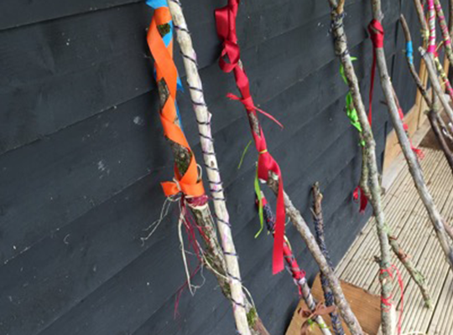

Step One
How to make a Journey Stick

Look outside and see if you can find a long straight branch or strong twig that you could use. Ideally it should be about shoulder height or slightly below to work well, but you could make a mini version if you prefer. You could even use an old broom handle or walking stick if you have one. To be safe, make sure that whatever you use does not have any rough or jagged bits and don’t be tempted to take live green branches from bushes or trees.

Step Two
A Pilgrim’s Dream

Make a paper or card shell and write your name on the front. On the underside write down your biggest hopes and dreams – don’t be afraid of writing something you’ve never told anyone before – take your time!

Make a hole and thread through some string or strong thread and then tie your shell to your journey stick.

Step Three
Treasure Chest

We are all unique and we all have things that make us special – look at this list of positive traits and choose one that you see in yourself.

Reliable Strong Fun-loving

Caring Thoughtful Forgiving

Trustworthy Giving Loyal

Look for something like button or bead in the matching colour to the word that describes you and tie it onto your journey stick. If you can’t find a bead or button try making one from card.

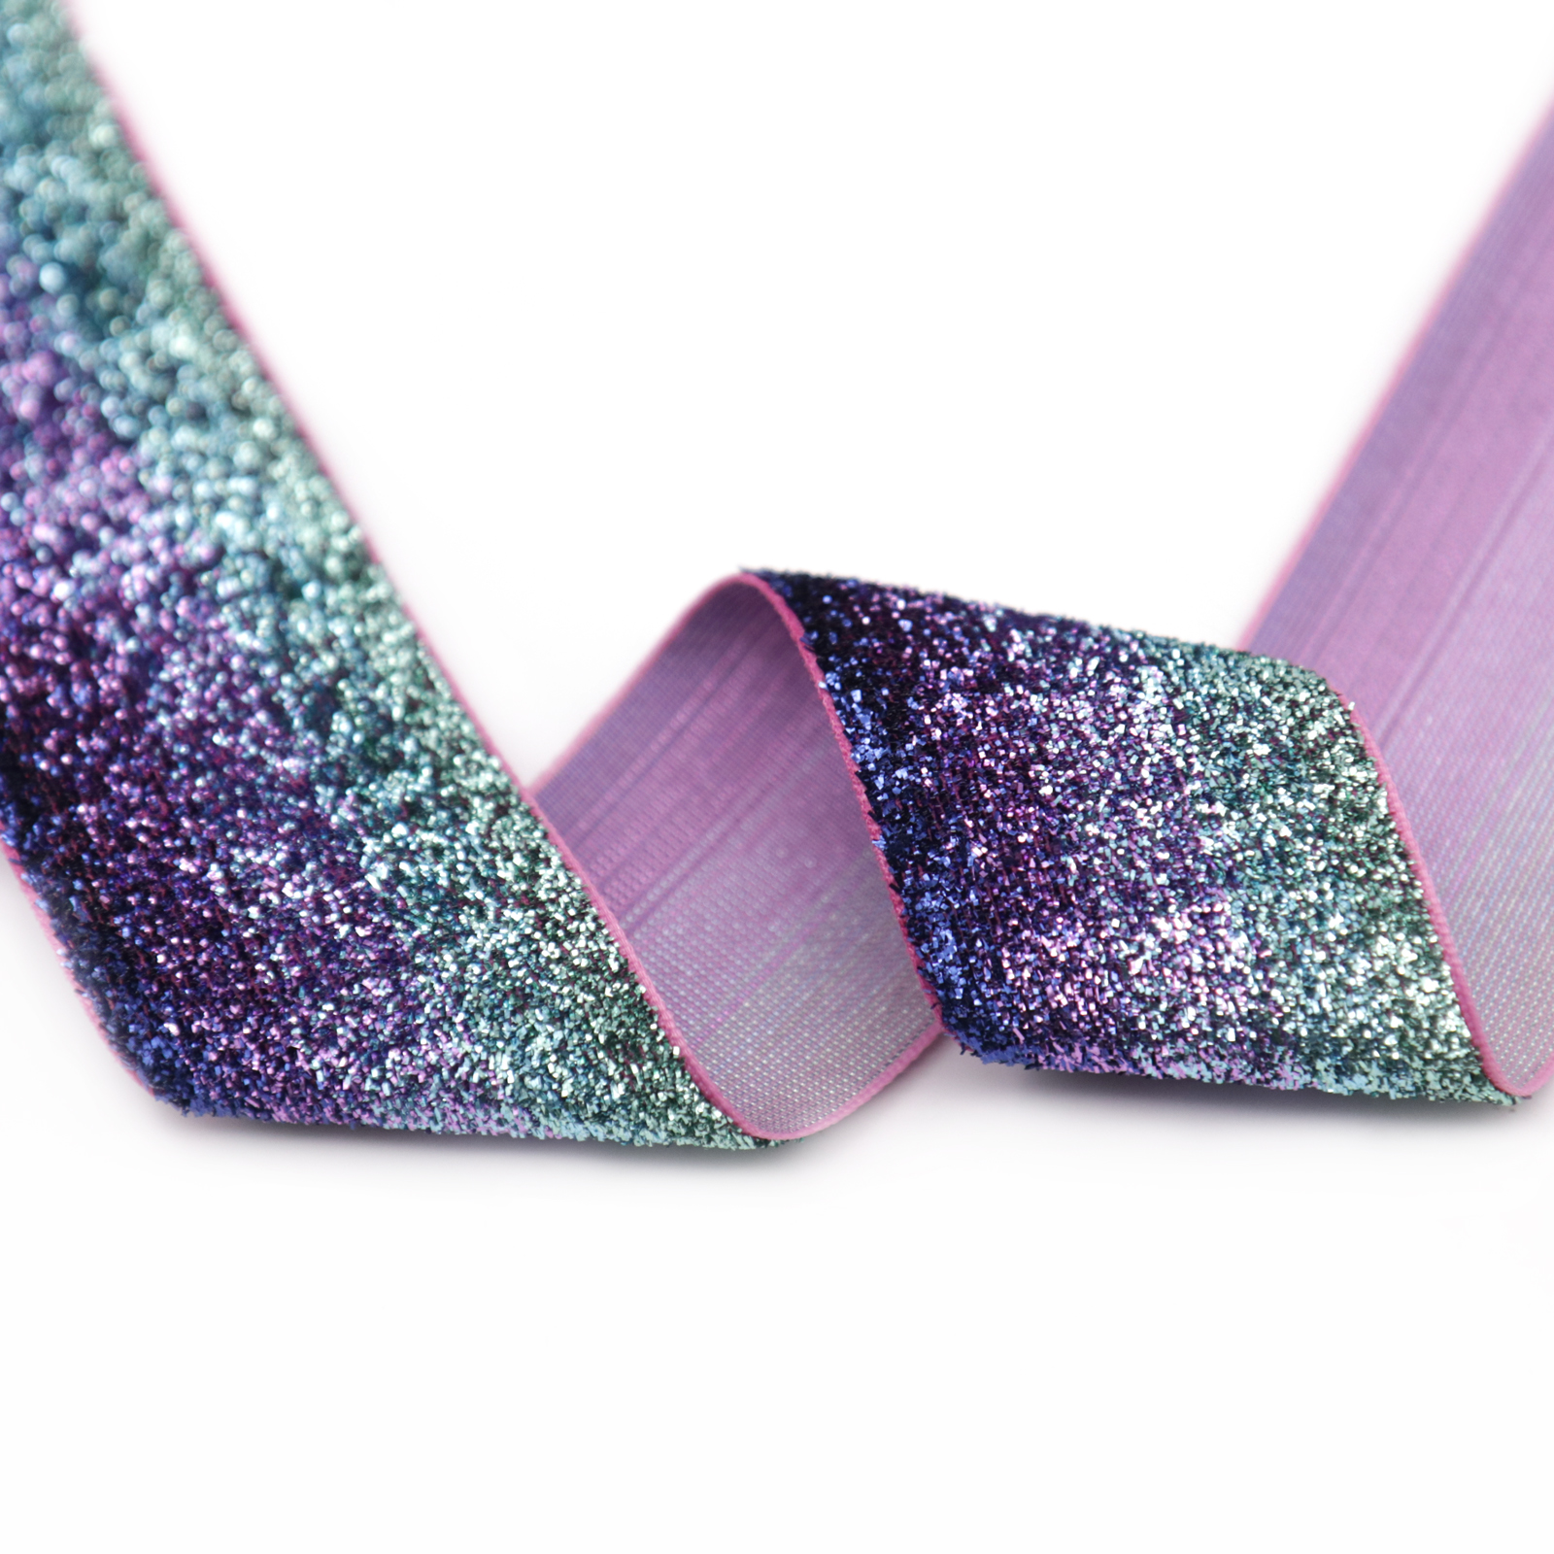
Step Four
Sparkle and Shine

Look for a strip of fabric, bright ribbon or something sparkly that you can tie on to your stick that you really like and makes you feel happy. This is for those friends who make you laugh, and for when you feel happy and excited Now tie it to your stick and share your joy with the people around you.

Step Five
Be kind to yourself
When you are feeling sad, what do you do to cheer yourself up? Go for a walk? Listen to music or watch a funny film? Look for some wool in your favourite colour to remind you to be a good friend to yourself. Now wind some around your stick to form another band.



Step Six
A special person

Wood is warm, solid, dependable. Find something small made of wood like a button, bead or small twig and add tie to your stick. As you add it think about someone who is there for you. This could be a parent, teacher or someone else who really cares about you and will help you when you need them to. Christians believe that God is always there for them.

Choose something to remind you of your special person.

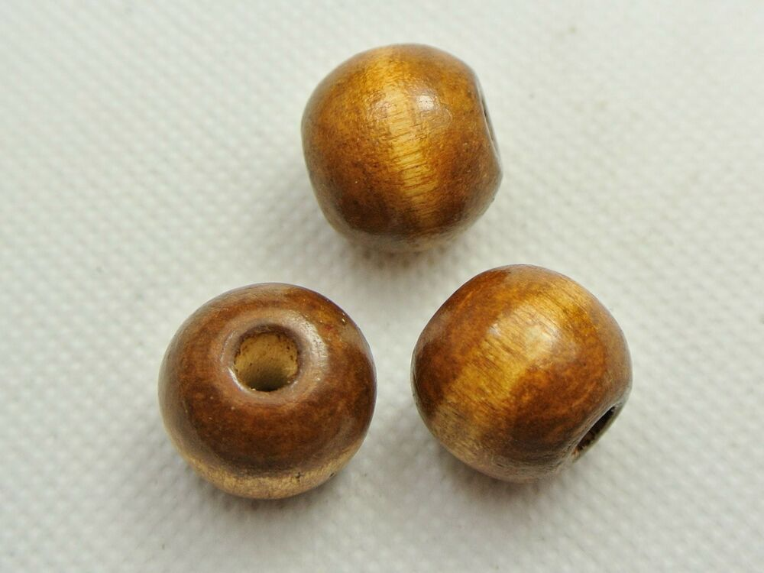

A Pilgrim’s Journey

In the Middle Ages (and still today) pilgrims travelled to the holy shrine at Santiago de Compostella in Spain, either as a punishment for sins or because they believed that St James, the brother of Jesus, was buried there. Once there, the pilgrims found scallop shells on the beach, which they would wear as evidence of their pilgrimage. Now the scallop shell is the universal sign of the pilgrim, used in many churches at baptism to symbolize the start of a Christian Pilgrimage through life.

