
Make your own Pilgrim Badge!
When Pilgrims went off on a pilgrimage they often wore badges made of silver or lead.
These badges were very individual and personal and they were made to tell other travellers something about the Pilgrim. These badges would have something on them which would tell people a little about themselves. Perhaps they were an excellent horse rider and owned lots of horses, then the badge might have a beautiful horse on it with the Pilgrim on top. Or perhaps they had been brave in a battle and so the badge would have a picture of their favourite weapons or a laurel wreath to show that they were the conqueror.
Sometimes they wore the badges to protect themselves like a lucky charm. These protective badges would perhaps have an angel on them.
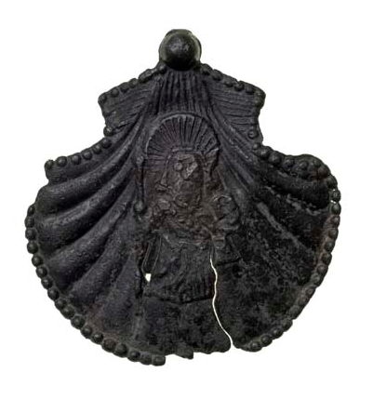 | 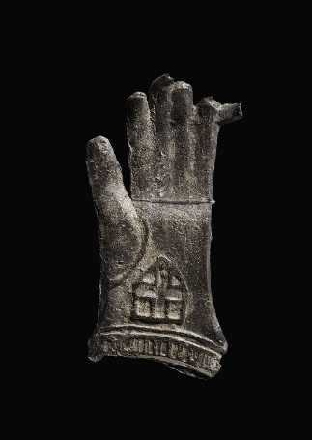 | 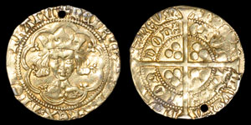
Before you begin to make your own Pilgrim Badges can you think of something that represents YOU!
You may have a favourite pet, or be good at a particular sport, or enjoy a special hobby.
You can use your initials if you want to.
You are going to draw and cut out something that represents you, but please don’t make it tooooooo fiddley and detailed.
Once you have an idea follow these instructions to make your own Pilgrim Badge!
You will need;
1) a square piece of strong card 7cmsx7cms approx or a circle about the size of a mug.
2) another piece of strong card which you can cut.
3) glue stick ( pritt is best)
4) string
5) hole punch
6)scissors
7)silver foil
8) sellotape
9)safety pin
How to make the Pilgrim Badge;
A) Draw the outline of something that represents you.
Eg the outline of your pet or animal you are passionate about......
Sports gear relating to a sport you like or excel at- rugby ball and post, cricket
bat and wicket, ballet shoes etc....
Or a badge from a club you belong to....
Or if you are really stuck, cut out your initials
B) Carefully cut them out and put them on your base piece of card and stick them on.
C) Now you are going to decorate the picture to make it more interesting. You are going to stick little pieces or card on to make the picture stand out.
You can use string eg for a horses mane and tail, or punch some card and use the holes to decorate your picture.
It is very effective to make a border round your card using string wiggled into a wave pattern , or lots of dots from the hole punch. Use your own imagination!!
D) Then cover as much of your badge as you can with glue.
Don’t worry about the stuck on decorations.
E) Take a piece of silver foil which is BIGGER than your badge. Lay it on the gluey badge silver side upwards, and press down carefully.
F) VERY CAREFULLY smooth the silver foil over the badge so that the relief of your picture and patterns underneath shows up.
G) Then fold the foil around the badge and secure with sellotape.
H) Finally take the safety pin and put a strip of sellotape over the straight bit ( not the pin bit! ) and stick it on the back so that you can use the pin to pin the badge onto yourself.

Good luck!!
Here are some which were made last year. Can you see what the badge tells you about the Pilgrim who made it?
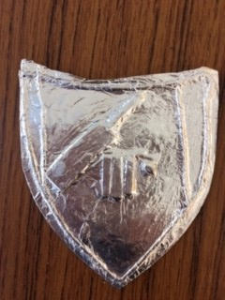 | 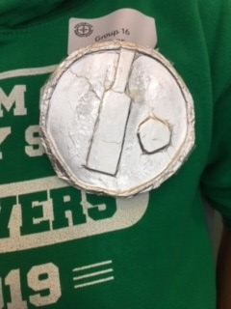 | 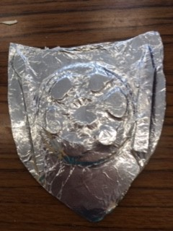
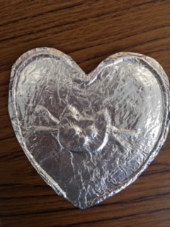 | 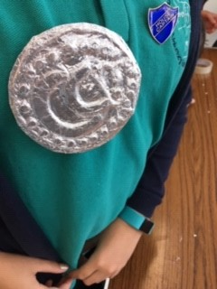 | 