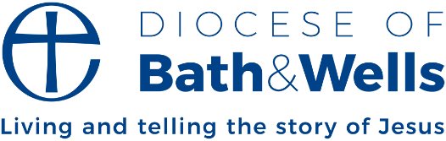

Bringing hope into the world
“A leader” said Napoleon Bonaparte, “is a dealer in hope.” At the start of 2025, this is a tough challenge for leaders everywhere! Conflicts continue around the world. The climate emergency is ongoing. At the polls, voters in many countries express their dissatisfaction with the status quo. As we look around us, can hope mean anything more than mere wishful thinking? As we look on all the challenges that exist, have we anything more to say than “I hope that that somehow, somewhere, something will turn up”.
More than ever, the Christian understanding of hope is what we need. Christian hope is broader, deeper, stronger altogether than any ‘wishful thinking’. In scripture, hope is not just a vague desire that something good in the future will somehow happen. Rather, the Biblical understanding of hope is of a confident expectation and desire that good in the future will come. It’s an assurance based in our pre-existing experience of God’s goodness, God’s love, the faithfulness that he has already shown towards us.
Scripture also contains the idea that while hope is something which comes primarily from God, it is also something in which human beings have a part to play, a contribution to make. The letter to the Hebrews says this: “God is not unjust; he will not forget your work and the love you have shown him as you have helped his people and continue to help them. We want each of you to show this same diligence to the very end, so that what you hope for may be fully realized.” (Hebrews 6:10-11)
God graciously calls us to join in bringing hope into the world. Our work, our love, our diligence matter. The contribution we make is important in bringing into being the future that God wants for us. At the start of this new year, we are called to take the lead: to be signs, symbols, dealers in the hope for which our world longs today.

Rt Revd Michael Beasley,
Bishop of Bath and Wells

