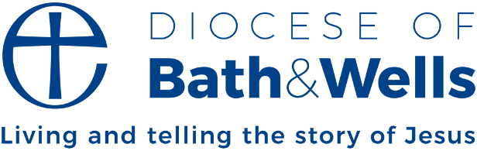

Christ beside us in the joys and sorrows of life

One of the great gifts of the Church, and to the Church, is the way in which we are invited to share in the significant life events of our communities. As we share in baptisms, confirmations and weddings, there is a great opportunity for us to be a part of people’s real lives in real ways.
A key moment in the Christian journey is the moment of Baptism. John Chrysostom in the C4th said, ‘When we immerse our head in water, just as if in a grave, the old man is buried, and having sunk down, is entirely hidden once for all; that, when we emerge, a new man arise again. Just as it is easy for us to be immersed and to emerge, so it is easy for God to bury the old man and raise up the new.’

For Christians baptism is important as it puts us in the place of Christ and we start a new way of life. We become part of Christ’s body. Titus 3.5 describes baptism as ‘the laver of regeneration’; it is an antitype of the Exodus (as we see in 1 Cor 10.1-2). It is us being born again from above (John 3.5). Above all, Baptism is the giving of the Spirit - which is the principle of the Christian Life.

It is our entire life, and indeed death, which are united in the death and resurrection of Christ. In Baptism we are united to God by adoption, having access to the divine life. And in Baptism we find ways of sustaining ourselves on the journey of life. As Lancelot Andrewes put it, ‘By Him taught all our life long that we know not, put in mind of what we forget, stirred up in what we are dull, helped in our prayers, relieved in our infirmities, comforted in our heaviness’.

Toby Wright
Dean of Wells

