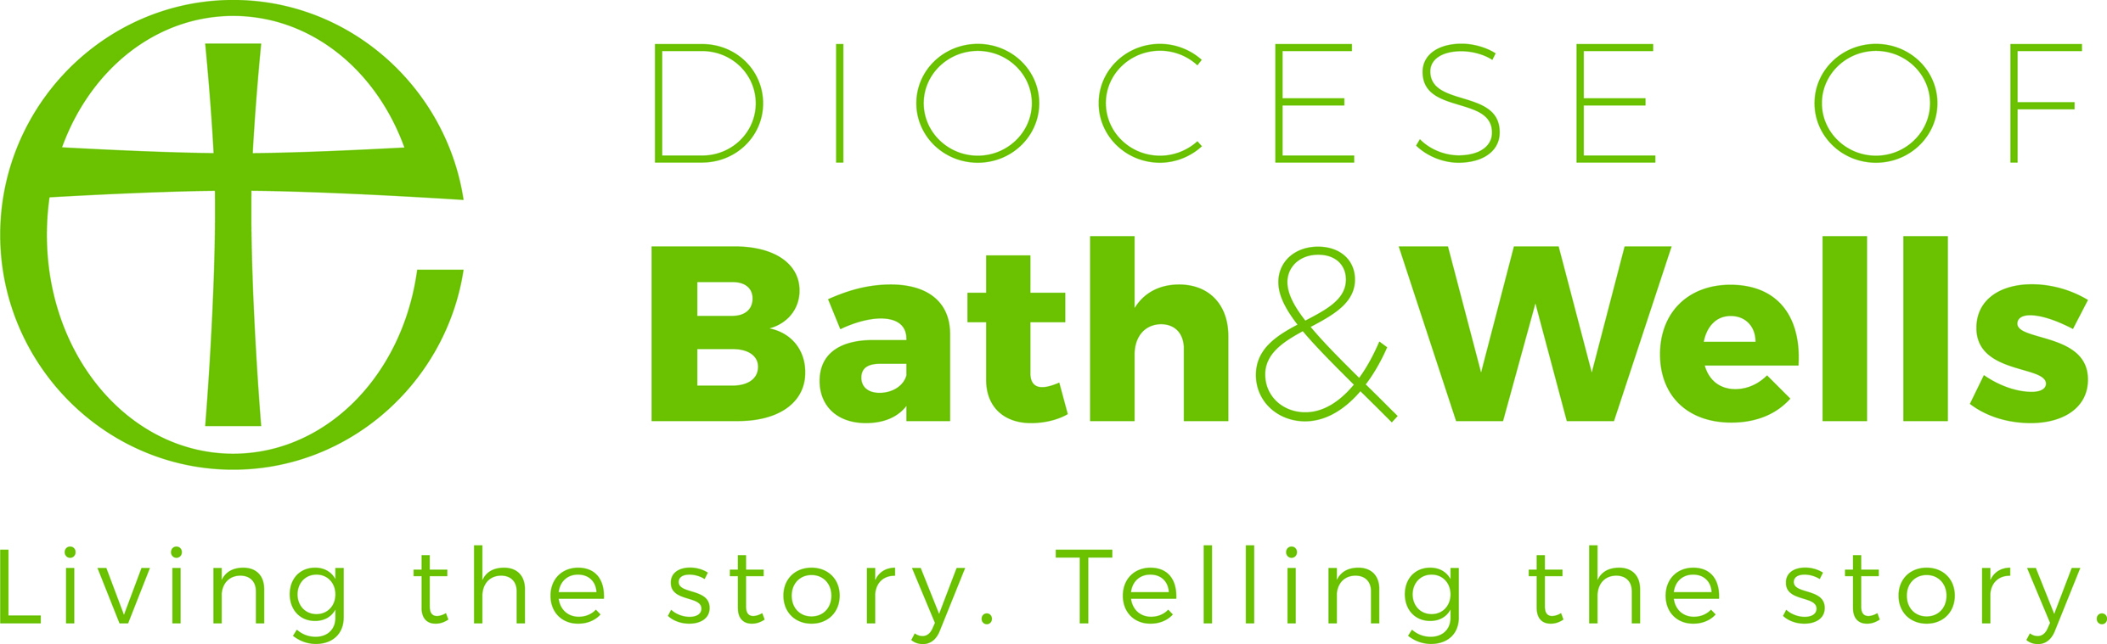

**Net Zero Support Assistant**

**(Fixed Term for 6 months)**

**Application Pack April 2023**

Contents

Recruitment Timeline

The Diocese of Bath and Wells

About the Role

Job Description

Person Specification

Main Terms and Conditions

Contact details

**For an informal discussion about the role, please contact:**

Sara Emmett

Climate Justice & Environment Adviser

[sara.emmett@bathwells.anglican.org](mailto:sara.emmett@bathwells.anglican.org)

**Human Resources**

Enita Andrews

Ph: 01749 685 113

[recruitment@bathwells.anglican.org](mailto:recruitment@bathwells.anglican.org)

Dear applicant

Thank you for your interest in the post of Net Zero Support Assistant with the Bath & Wells Diocesan Board of Finance (DBF). I am delighted to let you have details about the diocese and information about the post.

We hope you find the application pack provides all the information you need in order to consider your candidature for this post. If, however, you have any further questions please initially contact Human Resources.

Meanwhile, please find opposite, key dates for the appointment process. Should you decide to apply for this post we look forward to receiving your application and wish you well.

Kind Regards

Enita Andrews

**HR Manager**

**Applications**

Applications must be received by **noon Tuesday 25 April 2023.** Application forms, with a covering letter no more than one side of A4describing what attracts you to this role should be returned to Human Resources either by post to The Diocesan Office, Flourish House, Wells, BA5 1FD or by email to [recruitment@bathwells.anglican.org](mailto:recruitment@bathwells.anglican.org).

**Shortlisting**

To ensure the fairness of the selection process, shortlisting will be based upon the information which you provide in your application and assumptions will not be made about your experience or skills. Shortlisting will take place on **Wednesday 26 April 2023.** We will look for demonstrable evidence that you meet the criteria set out in the person specification. If after 3 weeks from the closing date you have not heard from us, please assume that you have not been shortlisted on this occasion. A copy of our privacy policy for job applicants can be downloaded from our website.

**Interview**

Interviews will take place in Wells on **Wednesday 3 May 2023**. Further details regarding the selection process will be communicated at the time applicants are invited for interview.

**Safeguarding**

We are committed to the safeguarding and protection of all children, young people and adults, and the care and nurture of children within our church communities. We will carefully select, train and support all those with any responsibility within the Church, in line with Safer Recruitment principles. This means that we will:

* Ensure that our recruitment and selection processes are inclusive, fair, consistent and transparent.
* Take all reasonable steps to prevent those who might harm children or adults from taking up, in our churches, positions of respect, responsibility or authority where they are trusted by others.
* Adhere to safer recruitment legislation, guidance and standards.

Further information can be found in our Safeguarding Policy available on the diocesan website. All applicants are required to complete a Confidential Declaration Form as part of our recruitment process when an offer of employment is made. This form is strictly confidential and, except under compulsion of law, will be seen only by those involved in the recruitment/appointment process and, when appropriate, the nominated safeguarding lead or someone acting in a similar role/position. All forms will be kept securely in compliance with the General Data Protection Regulation, 2018.



**The Diocese of Bath and Wells**

The Diocese of Bath and Wells is one of 41 Church of England dioceses in the country. The diocese stretches from Portishead in the north to Crewkerne in the south, Minehead in the west to Frome in the east.

The diocese loves and serves the 940,000 people who live here through its family of 466 parishes and 181 church schools. This family works for the good of local communities in a range of practical as well as pastoral ways: caring for the vulnerable in our societies, supporting local families and encouraging children and young people.

Everything the diocese does is underpinned by prayer and worship and is driven by our vision:

“In response to God’s immense love for us, we seek to be God’s people, living and telling the story of Jesus.”

If successful in your application, you will be arriving in the diocese at a time of significant change and you will have a role to play in the diocesan strategy, which has these three strategic priorities:

* To place mission and evangelism at the heart of all we do.
* To re-align our ministry resources towards mission.
* To identify, develop, and release the gifts of all our people.

**About the Role**

In 2020, the Diocese of Bath and Wells declared a climate emergency in response to the urgent environmental crisis and in recognition of our calling as Christians to the Fifth Mark of Mission *'To strive to safeguard the integrity of creation and sustain and renew the life of the earth’.* Following this, it presented an updated Action Plan which was further renewed in November 2022.

The Action Plan covers 5 key areas of work towards Net Zero (with other supplementary, wider, Creation Care commitments) that follow the recommendations from National Church to be included in Net Zero emissions scoping. These are carbon emissions from:

* Churches and church halls
* Clergy housing
* Staff travel
* Glebe land
* Schools (multi-academy trust and voluntary-aided schools).

To date, much has been achieved towards the targets contained within the plan, but additional support is required to better understand the baselines which we are working from and to promote change, engage, equip, and inspire those on the ground to pursue the goals of Net Zero Carbon and Creation Care through timely and informed action.

Therefore, we invite passionate and dedicated applicants to apply for the role of Net Zero Support Assistant, to become part of the Environment Team for a 6-month period.

More information can be found on our website <https://www.bathandwells.org.uk/faith/environment/>





**Job Description**

|  |  |
| --- | --- |
| **POST:** | **Net Zero Support Assistant (fixed term for 6 months)** |

|  |  |
| --- | --- |
| **Our vision** | In response to God’s immense love for us, we seek to be God’s people living and telling the story of Jesus. |

|  |  |
| --- | --- |
| **Key purpose of the post:** | The Net Zero Support Assistant is a supporting role working closely with the Climate Justice & Environment Advisor and engaging more broadly with key staff from other teams including but not limited to the Diocesan Board of Education, the Property Team, Buildings Advisor and Finance. Outreach work with Parishes and communities will also be paramount |

|  |  |
| --- | --- |
| **Location:** | Diocesan Office, Wells, Somerset. Will include travel across the Diocese. |

|  |  |
| --- | --- |
| **Reporting to:** | Climate Justice & Environment Adviser |

|  |  |
| --- | --- |
| **Hours of work:** | 18 hours per week, fixed term for 6 months |

|  |  |
| --- | --- |
| **Key relationships:** | Climate and Justice and Environment Adviser  Member of the Environmental Team  Acting Mission Development Team Leader  Church Buildings Adviser  National Church Environmental Team |

|  |
| --- |
| **Main Responsibilities:**   * Supporting engagement and progress for Ecochurch/Ecodiocese certification in churches and across the diocese. * Encouraging completion of the National Churches Energy Footprint Tool. * Collecting data to support funding applications and distribution of resources. * Assisting the development of the new Deanery Environmental Champions Network. |

**Person Specification**

|  |  |  |
| --- | --- | --- |
| **Area** | **Essential** | **Desirable** |
| **Qualifications, Knowledge and Experience** | * Educated to degree level in a relevant subject. | * Membership to a professional body and/or membership of/commitment to related bodies of which ongoing professional development is available. |
| **Skills, Competencies and Abilities** | * Excellent communication skills and ability to engage and enthuse a wide range of stakeholders. * Experience of data collection and assimilation. | * Experience of supporting funding applications or project management. |
| **Work Related Personal Qualities** | * A proven passion for sustainability and Creation Care issues. |  |



**Main Terms and Conditions**

|  |  |
| --- | --- |
| Hours of Work | 18 hours per week (flexible, but to include one regular day)  Fixed term for 6 months due to funding.  Core office hours are 9am until 5.15pm Monday to Thursday and from 9am to 5pm on Fridays with an hour unpaid lunch break taken as appropriate. Some (but not frequent) evening and weekend work may be required. Hybrid and flexible working will be considered. |
| Salary | £24,590 per annum, pro rata. Actual salary £12,295 per annum. |
| Pension | Pension Scheme administered by the Church of England Pensions Board. The employer will contribute 10% of the employee’s pensionable salary and the employee may choose to make an additional voluntary contribution of any proportion of their pensionable salary. |
| Holiday | 25 days per calendar year plus bank holidays (pro-rata for part-time staff)  The holiday year runs from 1 January to 31 December.  Additional discretionary days are given at Christmas and Easter. |
| Expenses | All reasonable working expenses will be met at the agreed Diocesan rates. |
| Probation | This post will be subject to a probationary period. |
|  |  |

