Safeguarding Newsletter – July 2023

Wishing you all good health as we work our way through a sadly typical wet British summer. Our newsletter this month contains some important information on changes that will be coming in the arena of DBS checks. I would welcome you all sharing this news with your incumbents or others involved in that important work. I would also like to take this opportunity to thank all our wonderful volunteers who continue to do a fantastic job in supporting the most vulnerable people in our communities. I would also like to thank my team who have worked incredibly hard all year to support you and me.

Safeguarding Sunday – 19th November 2023
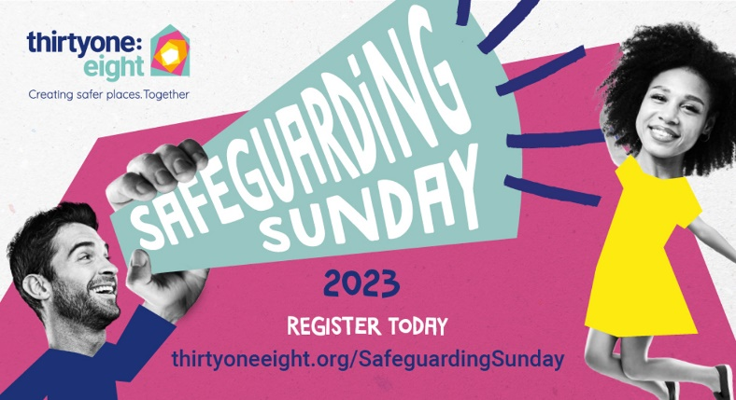
It is almost that time of year again folks. After a very successful event in 2022 we are looking to do even better this year. It really is a chance to celebrate all that your parish does to protect children and vulnerable adults. To register click the following link. Safeguarding Sunday | Thirtyone:eight (thirtyoneeight.org) I’m also asking for volunteers who can promote the event on your websites and social media streams. Perhaps you could include a short video, or photo of your church, alongside a description of what it is to be a part of a faithful and safe church community.

DBS checks
Firstly, just to say thank you for the vast improvements in information sharing around DBS checks. There is some quite exciting news to share about DBS checks that we hope will make life easier for our fantastic volunteers. We are working with the Christian safeguarding charity thirtyone:eight to move our DBS provision from our current provider, Matrix, to them with an anticipated start date of late November / early December. This will provide the following improvements:
- The ability to use digital ID checks. People can upload their ID straight to the system rather than having to travel to have it checked by a PSO. (However, that option is still available)
- Parishes will be able to fully complete and submit their own checks rather than having to go via the diocese, saving substantial time.
- Benefices will be able to access and complete checks on all parishes within the Benefice. This will offer more flexibility.
- Specialist advice and support, if required, by thirtyone:eight’s dedicated DBS team and also from your diocesan Safeguarding team, if preferred.

To reassure you, the system used will be exactly the same as it is now and there will be online training and ‘how to’ videos etc available for anyone who currently finds this process challenging.
Why are we doing it? We believe this approach will reduce the amount of time spent by PSO’s in checking IDs and having to get countersignatures from the diocese. Additionally, as a diocesan team we are spending approximately 36 hours a week administering DBS checks. This time could be better spent providing more one-to-one support to parishes in areas such as auditing safeguarding practice and supporting dashboard completion.
What do you need to do? Over the next month or so, Leonie will be emailing new starter forms to all of our existing PSO’s. We will be collating details of who within each benefice would like to be a DBS checker. If you can respond as quickly as possible that would be appreciated.
How much is this costing? The cost of providing digital ID checks will be met by my departmental budget. The annual cost of using thirtyone:eight has also been met by finding savings elsewhere in my budget and as such for the 3rd consecutive year our budget remains at a similar level.

Staff availability over the summer
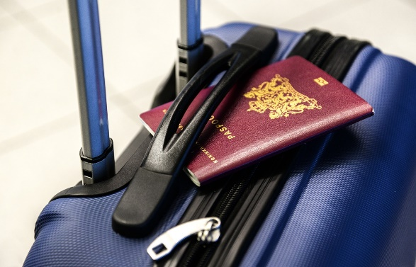
Please note that whilst we continue to provide support over the summer holidays there will be periods where we are quite short. I will be away on holiday from 9 August until 28 August, however, Joanne Austin will be around to take any referrals or provide you with advice. Please consider using the online reporting tool for safeguarding referrals Confidential incident/concern form - Bath and Wells Diocese as we are exceptionally busy and it isn’t a role where we are always sat at our desks.

Training
As mentioned last month, our safeguarding training will pause for August. This will enable our trainers to get ready for the newly developed leadership training which starts in September. Dates will be released in the middle of August as we need to work on new handbooks and processes before they can be opened up.
We are working on plans to run a train the trainer course (to support parishes delivering online safeguarding courses in person where people struggle with IT use) and a PSO induction course in October. We will also be running a chaplaincy safeguarding event later this year and a spiritual direction safeguarding event in the new year.

The Safeguarding team will also be attending the Churchwarden Days in July and September.

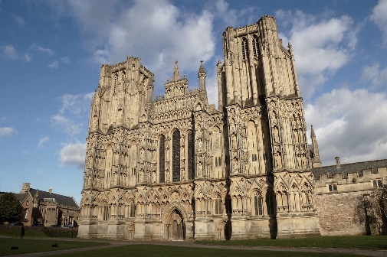
Wells Cathedral
Did you know the Diocesan Safeguarding team also provides safeguarding services to Wells Cathedral? If you also volunteer, there and have a safeguarding concern please contact Jo or I. Jo works from Wells Cathedral one day a week.

Out of hours cover
Another reminder that The Diocese of Bath & Wells partners with thirtyone:eight in relation to accessing the safeguarding Helpline on 0303 003 1111 during out of hours (It operates 5pm - midnight on Mon-Fri; 7am - midnight on Sat and Sun), on bank holidays and other absences. This service is being chronically under used in comparison to the high volume of out of hours calls I used to receive. thirtyone:eight are a Christian safeguarding organisation and work closely with many dioceses. They offer the same advice that we would give and should be your first point of contact out of hours.

Parish Safeguarding Officer Forum
Our next forum will be on Wednesday, 11 October at 4pm. (details will be provided nearer the time) If you are attending these meetings but would like an update following them, please let me know.

Safeguarding posters
We have a number of safeguarding posters and dashboard leaflets left over from the last Clergy Day. If you would like one, please drop into the safeguarding office in Flourish House.

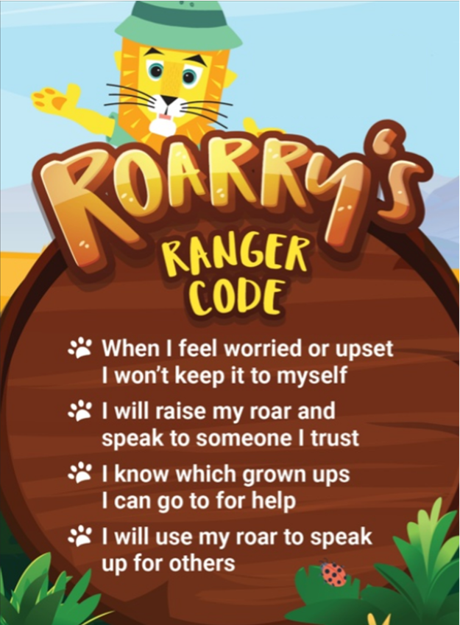
Raise Your Roar – Safeguarding resources for children.
Raise your Roar with Roarry! (thirtyoneeight.org)

Are you a church that runs a lot of activities with children? Do you want resources you can use with children to teach them about staying safe? If you do, then you may be interested in thirtyone:eight’s Raise Your Roar campaign. Please see the above link for more details.

Song launched to help children learn to speak out (thirtyoneeight.org)

With warm wishes
Ben
Ben Goodhind
Diocesan Safeguarding Manager
Diocese of Bath and Wells
Diocese of Bath and Wells – Safeguarding team
 |  | 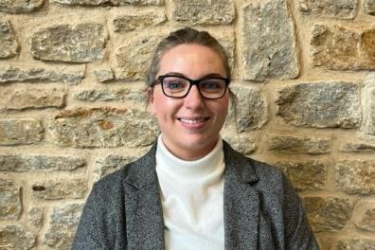
Ben Goodhind, Safeguarding Manager  01749 588917  Ben.Goodhind@bathwells.anglican.org |  | Jo Austin, Safeguarding Caseworker  01749 588905  Joanne.Austin@bathwells.anglican.org
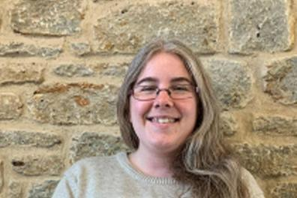
Leonie Jones, Safeguarding Coordinator
01749 588907
Leonie.Jones2@bathwells.anglican.org

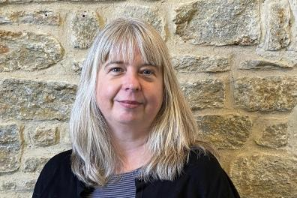 |  | 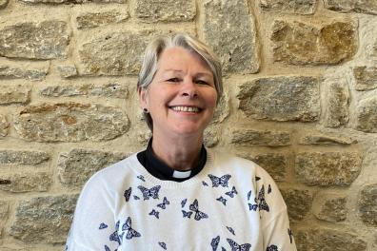
Enita Andrews, Safeguarding Trainer  training.safeguarding@bathwells.anglican.org |  | Jacqueline Keir-Bucknall, Safeguarding Trainer  training.safeguarding@bathwells.anglican.org

