May/June Safeguarding Newsletter

Welcome to the latest edition of our newsletter. The Safeguarding team has been incredibly busy this year so I do apologise that we have not always been able to respond as quickly as we would like. Jo and I undertake all the advice and casework for 470 parishes and Wells Cathedral. Our roles involve a lot of travel across the diocese meeting people who are subject to safeguarding agreements and undertaking investigative work. Additionally, as Diocesan Safeguarding Manager, I’m touring Deanery Chapter meetings (please invite me) and taking part in regional, national and diocesan events. Unfortunately, this means we can’t always answer the phone immediately.

To help you access support quickly I wanted to outline the different ways you can contact a member of the team. We have worked hard to ensure we can better triage requests and manage our workload.

- DBS and safer recruitment queries: We get several hundred a week during busy times and these need to go to dbs.safeguarding@bathwells.anglican.org These are answered in date order of receipt and usually within 48 hours. Thirtyone:eight manage our DBS provision and can also be contacted for advice on 0303 003 1111.

- Training: Please email queries about training to training.safeguarding@bathwells.anglican.org Our trainers, who work Wednesdays and Thursdays, will respond to you as quickly as they can. If you have an urgent query that can’t wait, please contact Leonie.

- Safeguarding Referrals: If you can’t reach Jo or me by phone please use our online referral Confidential incident/concern form - Bath and Wells Diocese A reminder that safeguarding concerns need to be reported within 24 hours. We will respond to you within that timeframe upon receipt. Where possible, please avoid submitting urgent referrals at 4.59, as we need time to respond. We have been receiving a large volume of calls in this way and we do not have the team size to handle these effectively at the last minute.

- Help with Dashboards: Please email Safe.Guarding@bathwells.anglican.org By doing this we can ensure all team members are aware of your request for help meaning you will get a quicker response.

As always, I’m really keen to be able to provide an excellent service. I’m happy to meet anyone online or in person to help with any safeguarding support you need.

In person Parish Safeguarding Officer Forum (Save the Date!)
The next forum will take place Wednesday, 10 July, at 7pm. This will be an in-person forum. We will confirm the venue shortly. In the meantime, please register your interest so we can confirm attendance. Based on your feedback, we are trailing a later start time and in person format. If successful we plan to take this to all three archdeaconries.

Parish Dashboards Support Event in Wells.
Are you anxious about using dashboards or haven’t had time to get started? The Diocesan Safeguarding team are holding a support workshop at Flourish House, Wells, 4 July, 2-4pm. Please register your interest training.safeguarding@bathwells.anglican.org The plan is to use this event is to get you onboard with your own dashboard and build your confidence in using it effectively. Additionally, we will be holding an evening workshop on a Wednesday after the summer holidays, if that timing works better for you. The date for that workshop is to be confirmed.

Safeguarding Sunday 2024
Safeguarding Sunday | Thirtyone:eight (thirtyoneeight.org)
Here is a link to this find out more about this year’s Safeguarding Sunday event on 17 November. I understand that the timing of this event may not be ideal for everyone so, please hold an event at a time that works best for you. This year, I’m really interested in learning about the ways in which you help protect vulnerable people in your parish. If you have any clubs, groups, or events we can celebrate and share, with the help of our excellent Communications team, please do email me directly. My contact details are available at the bottom of this newsletter.
Job 5:15-16 “He saves the needy from the sword in their mouth; he saves them from the clutches of the powerful. So the poor have hope, and injustice shuts its mouth.”

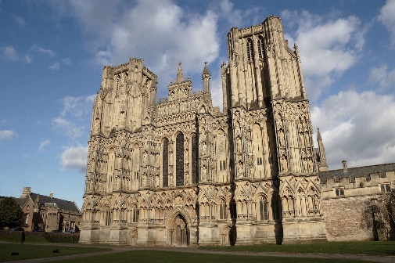
Wells Cathedral
Did you know the Diocesan Safeguarding team also provides safeguarding services to Wells Cathedral? If you are a cathedral volunteer, you can contact me or Jo with any safeguarding concerns. Jo works from Wells Cathedral one day a week.

Safeguarding Coordinator vacancy
We currently have a vacancy for a Safeguarding Coordinator (maternity cover 😊). The role is full-time but part-time could be considered.
The closing date for applications is 9am, Monday 24 June and interviews will be held on Wednesday 3 July.
More information about the role can be found on the vacancies section of the diocesan website. https://www.bathandwells.org.uk/-vacancies/diocesan-staff/safeguarding-coordinator-maternity-cover.php
Please do share this with your networks and with anyone you think may be interested. Ben is happy to be contacted for an informal discussion about the role.

Diocese of Bath and Wells – Safeguarding team
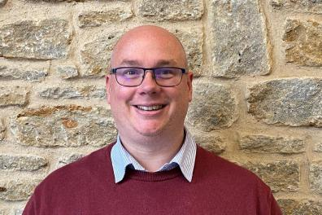 |  | 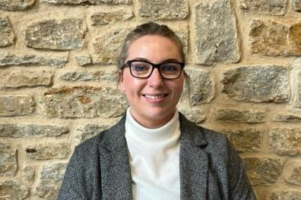
Ben Goodhind, Safeguarding Manager  01749 588917  Ben.Goodhind@bathwells.anglican.org |  | Jo Austin, Safeguarding Caseworker  01749 588905  Joanne.Austin@bathwells.anglican.org
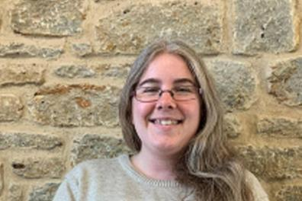
Leonie Jones, Safeguarding Coordinator
01749 588907
Leonie.Jones2@bathwells.anglican.org

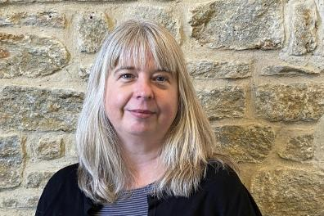 |  | 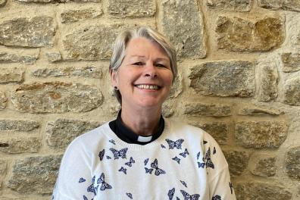
Enita Andrews, Safeguarding Trainer  training.safeguarding@bathwells.anglican.org |  | Jacqueline Keir-Bucknall, Safeguarding Trainer  training.safeguarding@bathwells.anglican.org

Out of hours cover
Please contact the safeguarding Helpline on 0303 003 1111 during out of hours (It operates 5pm - midnight on Mon-Fri; 7am - midnight on Sat and Sun), on bank holidays and other absences.

