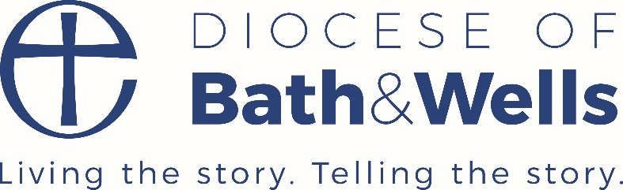
Governance Strategy
Strong, effective, ethical governance
September 2017
The purpose of this strategy is to set out the Diocese of Bath and Wells’ approach to securing effective and ethical governance of its schools and its role in supporting this within the context of its core Vision and values, and local and national developments.
“In order to enable the continued development of successful schools, high quality governance is essential… The governance of our schools cannot be left to chance; schools need governors with the right skills and gifts to provide strategic oversight and direction.”
A Diocesan Board of Education for the future – July 2013
That they shall have life, life in all its fullness
JOHN 10.10

Vision and Purpose

There is a real aspiration within the Church of England to ensuring that its schools are effective, rooted, distinctive and inclusive, and as such, governors as leaders within our schools are key partners in the achievement of this aspiration. Schools need governors with the right skills and gifts to provide strategic oversight and direction.

Given the rapidly shifting educational environment, there is an increased sense of accountability for standards and the quality of provision within our schools. We have an expectation that we will support governors in our schools to uphold our Vision “That they shall have life, life in all its fullness” through providing them with the tools to do so in order to make our schools centres of excellence where all children thrive and flourish

Aims / Intended outcomes
The Ten Marks of a High Performing DBE ( July 2013 ) give a clear aspiration in terms of governance :
“Governance and leadership in all diocesan schools are deemed good or better and every school has a sufficient number of high quality foundation governors in post to ensure good strategic governance.”

We know that a strong, well-led governing body, supportive of the school, its staff and its mission, makes an important contribution to the school’s well-being and effectiveness.
Being a governor is a major piece of Christian and community service.

Effective and values – led governance in our schools
We seek governance in all our schools which :
- Strives for and achieves the highest possible standards of education and outcomes for our children
- Maintains and develops the Christian ethos and character of our schools
- Upholds and develops the core values and principles as embodied in our Vision John 10.10
- Ensures that there is clarity of Vision, ethos and strategic direction
- Provides clear and strong strategic leadership and accountability and appropriate challenge
- Builds effective relationships with its parish and community partners
- Has robust systems of self-review in place which identify both strengths and areas for development for governing bodies
- Demonstrates impact on school performance and improvement
- Fulfils its statutory roles and responsibilities

We will support and empower our governors to achieve these aims though :

- A culture of partnership and collaboration where the voice of governors is key
- Ensuring that our shared vision is shared and developed and that church school distinctiveness is maintained and developed
- Nurturing our governors in developing their skills, knowledge and gifts
- Using a strong and shared evidence base including data and local intelligence so that we know our schools and their strengths and areas for development
- Enabling our governors to access high quality training, advice and up to date information
- Working with key partners such as our local education authorities to provide a cohesive and clear package of support which is communicated effectively to our governors
- Responding to the needs of individual governing bodies as well as providing a core package of support
- Providing direct services, brokering services or signposting to services as appropriate
- Growing our governance base by actively recruiting high quality governors
- Quality assuring the core and wider offer of training and services
- Facilitating Peer to peer support networks and the dissemination of good practice and case studies
- Monitoring the effectiveness of our strategy in terms of outcomes

Contacts
Key officers with responsibilities for governance
School Improvement – Helen Fenn, Deputy Director of Education
School Organisation – Suzanne McDonald, Malcolm Barton
Training – Jan Chandler
OUR OFFER

School Organisation
- Functions and process : Instrument of governance, appointment of foundation governors, renewing of appointments, DBE Approval,
- Buildings and Premises : LCVAP, governor 10% liability in V A schools
- New models : collaborations, academy conversion, MAT, advice and support , new builds, federations
- Legal issues : reconstitution, new legislative requirements
- Training ( see Appendix )
- Mapping tool
- School admissions

School Effectiveness
- Headteacher recruitment
- Reviews of governance
- Deployment of National Leaders of Governance
- Strategic leadership, vision and ethos
- Monitoring and evaluation
- Quality of teaching and learning
- Ofsted preparation
- Skills audit
- Use of data
- Parental and community engagement and engagement with pupils

Church School Distinctiveness – Training offer & Advisor visits
- Churches and church schools in partnership
- Ways of working together
- Clerks to governors annual forum
- Promoting children’s spiritual development
- Church school distinctiveness for new governors
- Developing an ethos group
- SIAMS
- Headteacher recruitment
- Pupil voice

How we will deliver / facilitate the delivery of the above offer
- Core package – direct delivery
- Bespoke training and response /support for individual FGBs / co-ordinated package of support for vulnerable schools facilitated by the Diocese
- Bespoke offer for MATs and LGBs
- Signposting and brokerage
- Facilitation of support networks including via the FEL network on governance
- The sharing of information between appropriate people and bodies supporting our schools, both within the Education department and beyond the Diocese,, such as LAs, MATs etc

Partnerships
- Local authorities
- MATs
- RSC
- National Governor’s Association
- National leaders of governance
- Teaching School alliances
- Parishes
- Bath and Wells multi-academy trust
- DfE
- Ofsted
- HMI

Key Priorities September 2017 – January 2019

- To maintain and enhance our in-house training offer
- To ensure that foundation governors are upskilled appropriately to fulfil their role
- To ensure that all governing bodies are aware of the implications of the new SIAMS Framework
- To use both our own data analysis to identify governing bodies where schools are at risk and to work with appropriate partners to insure a package of support is in place.
- To actively recruit new foundation governors, ,members and directors
- To ensure that the education department current staffing and resources are robust and co-ordinated in meeting the needs of this strategy
- To ensure that governors are fully aware of and supported in any choices they may make towards academisation
- To ensure that governors within small rural schools are supported to secure governance within these settings.

