John O’Donahue – A Celtic Blessing for Leaders – dedicated to a special friend
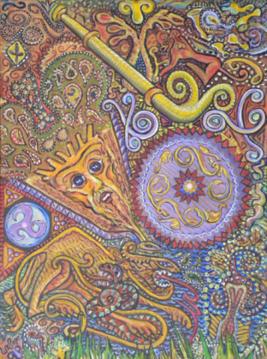

JOHN O’DONAHUE – A BLESSING FOR LEADERS

MAY YOU HAVE THE GRACE AND WISDOM TO ACT KINDLY,
LEARNING TO DISTINGUISH BETWEEN WHAT IS PERSONAL AND WHAT IS NOT.
MAY YOU BE HOSPITABLE TO CRITICISM.
MAY YOU NEVER PUT YOURSELF AT THE CENTRE OF THINGS.
MAY YOU ACT NOT FROM ARROGANCE BUT OUT OF SERVICE.

MAY YOU WORK ON YOURSELF, BUILDING UP AND REFINING THE WAYS OF YOUR MIND.
MAY THOSE WHO WORK FOR YOU KNOW YOU SEE AND RESPECT THEM.
MAY YOU LEARN TO CULTIVATE THE ART OF PRESENCE IN ORDER TO ENGAGE WITH THOSE WHO MEET YOU.

WHEN SOMEONE FAILS OR DISAPPOINTS YOU, MAY THE GRACIOUSNESS WITH WHICH YOU ENGAGE
BE THEIR STAIRWAY TO RENEWAL AND REFINEMENT.
MAY YOU TREASURE THE GIFTS OF THE MIND THROUGH READING AND CREATIVE THINKING
SO THAT YOU CONTINUE AS A SERVANT OF THE FRONTIER
WHERE THE NEW WILL DRAW ITS ENRICHMENT FROM THE OLD, AND YOU NEVER BECOME FUNCTIONARY.

MAY YOU KNOW THE WISDOM OF DEEP LISTENING, THE HEALING OF WHOLESOME WORDS,
THE ENCOURAGEMENT OF THE APPRECIATIVE GAZE, THE DECORUM OF HELD DIGNITY,
THE SPRINGTIME EDGE OF THE BLEAK QUESTION.
MAY YOU HAVE A MIND THAT LOVES FRONTIERS
SO THAT YOU CAN EVOKE THE BRIGHT FIELDS THAT LIE BEYOND THE VIEW OF THE REGULAR EYE.

MAY YOU HAVE GOOD FRIENDS TO MIRROR YOUR BLIND SPOTS.
MAY LEADERSHIP BE FOR YOU A TRUE ADVENTURE OF GROWTH.
REPORT THIS ADPRIVACY SETTINGS
* *
REPO

