Signing up for the Church of England eLearning Portal
- Click or paste the link to the portal landing page at https://safeguardingtraining.cofeportal.org/.

- Beneath the login box select ‘create new account’.
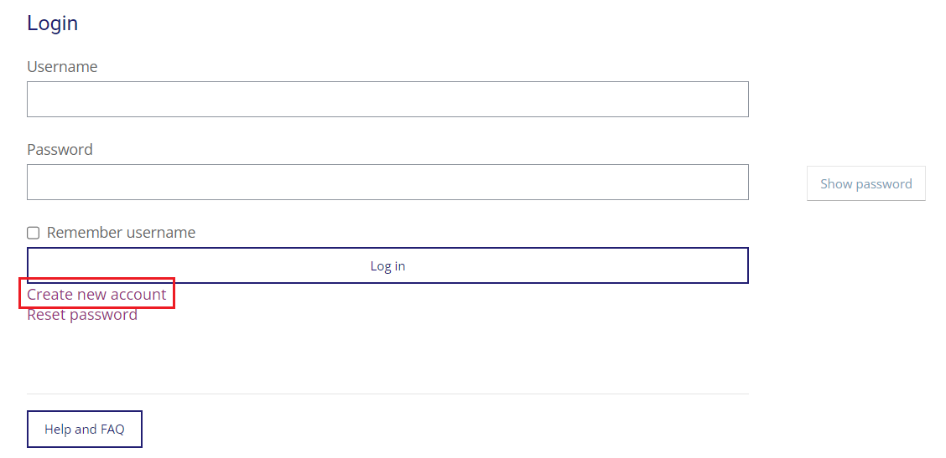
- The next page is the Safeguarding Training Privacy Policy. Click show/hide to read the various sections then click ‘I agree to the Safeguarding Training Privacy Policy’.

- Choose your username and password. There is guidance on what the username and password should contain on the screen. You may wish to use your email address as your username for ease.
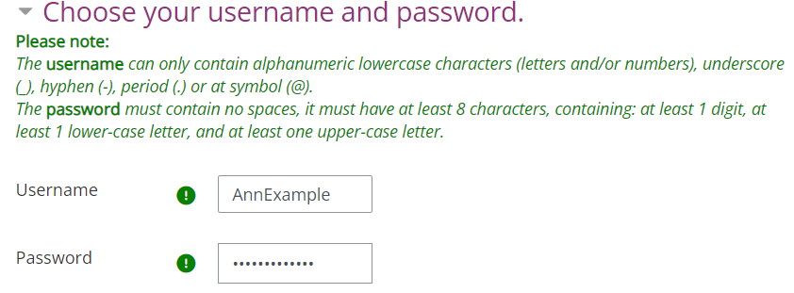

- Input your details.
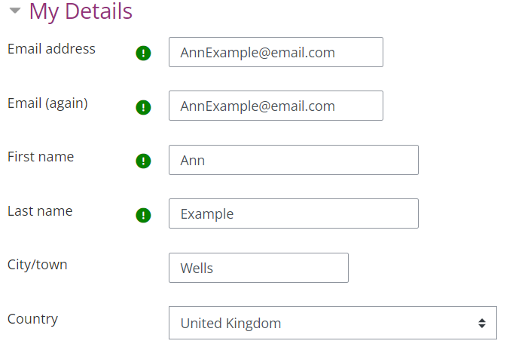
- Input the organisation details.
- Your diocese is Bath and Wells.
- Select the relevant training institution, if needed. If you are not part of a training institution, select ‘Not part of a Training Institution’.
- If you are involved at a cathedral select the relevant option. If not select ‘Not involved at a Cathedral’.
- Input your church’s town and name, and your role.
- The last box can be left blank.
- Finally, click ‘create my new account’.
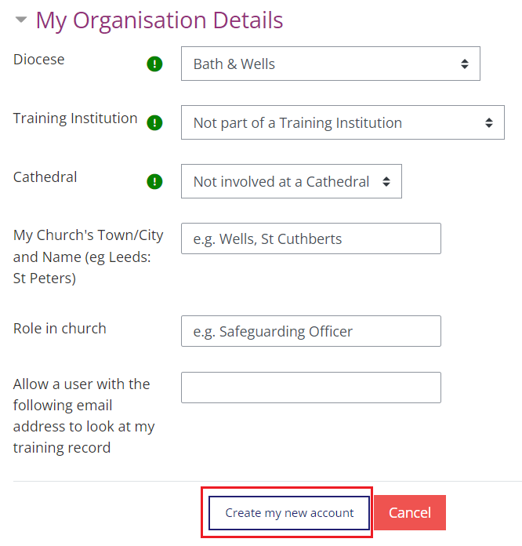

Any errors will be highlighted in the form for you to correct. If the form does not submit, or if any error cannot be corrected, please contact the helpdesk at elearning@safeguardingtraining.cofeportal.org and they will be able to help you directly.
If you already have an account and are having trouble logging in, the helpdesk will be able to assist you.

