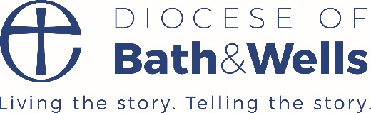

**Young Vocations Ministry Experience Scheme**

The Diocese of Bath and Wells is excited to offer a Ministry Experience Scheme for a trainee (MET) to explore their calling in a ministry context. The Ministry Experience Scheme will provide a parish, deanery or Christian organisation that will enable the MET to:

* Gain ministry experience
* Exercise specific gifts in a ministry context
* Explore calling alongside the Vocations Team
* Study and have time to reflect
* Develop a rhythm of personal devotion and prayer

The ministry experience will include:

* 10 hours per week in a supervised placement that will provide a variety of work experiences to explore calling. This will include local supervision and meeting with a person for theological reflection.
* 6.5 hours per week spent at with a selected training institution to study, reflect and worship in community with other trainees and interns over three eleven week terms.
* Opportunities to work across the Diocese with regular supervision and support from the one of the diocesan Go Team Advisors.

The MET will be employed by the DBF for 18 hours per week on the Living Wage. T**his equates to a salary of £7,866 for the duration of the scheme.** You will be allocated a placement when appointed.

Fixed term contract from September 2021 to July 2021.

For more information, download the application pack.

Completed application forms should be returned to: [recruitment@bathwells.anglican.org](mailto:recruitment@bathwells.anglican.org)

**Closing date:** Friday 16 July 2021

