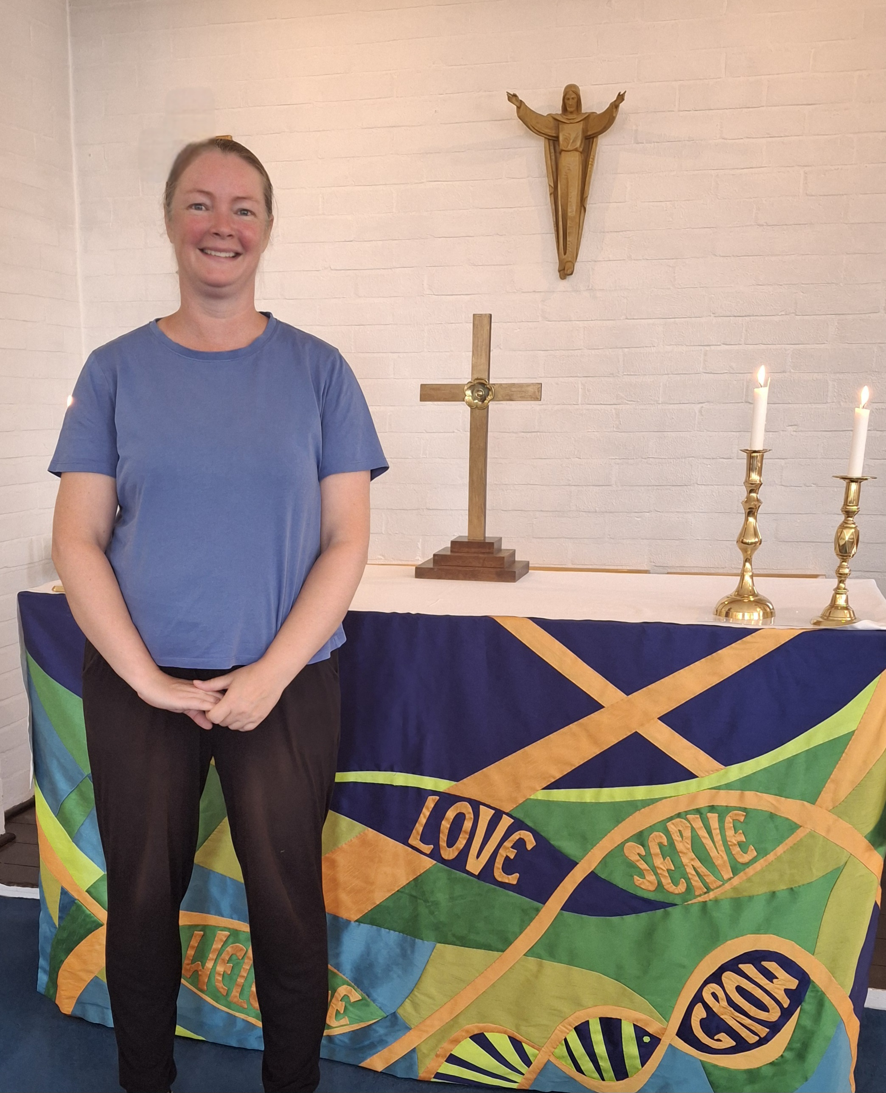
My Christian faith has shaped every stage of my life. Raised in a committed Christian family, I came to faith as a child and was baptised at the age of eleven.
Whilst at school, I realised a great love for reading and researching, and this remains to this day.
I served for five years in the British Army as a Military Clerk in the Adjutant General's Corps, where I learned the importance of discipline, integrity and teamwork. As an Army spouse for more than twenty years, I have experienced the challenges and opportunities of frequent change, learning resilience, adaptability and the importance of strong communities.
Today I work as an Administrator within the Osteoporosis and Fracture Liaison Service at Yeovil Hospital. Through this role I contribute to the care and wellbeing of people across our local area and continue to develop the organisational, communication and administrative skills needed for effective governance.
Alongside my professional life, I have sought to grow in faith through regular prayer and study of Scripture. Living with Obsessive-Compulsive Disorder has brought its own challenges but has also deepened my dependence upon God and strengthened my compassion for others who live with unseen struggles.
I am an active member of St Peter's Church, Yeovil, where I serve on the PCC and Deanery Synod. I greatly value the opportunity to work prayerfully with others in discerning God's direction for the Church and supporting its mission. I am also involved in our church sewing group, helping create altar frontals and banners which enrich our worship and witness.
The Church of England faces important opportunities and challenges in this generation. As General Synod continues to address questions around mission and church growth, support for local parishes, safeguarding, discipleship, encouraging younger generations, and stewarding resources wisely, it is vital that decisions are rooted in Scripture, shaped by prayer and informed by the realities of parish life.
I believe the Church's primary calling remains the same: to proclaim the gospel of Jesus Christ, make disciples and serve our communities with the love of God. As a lay representative, I would seek to contribute thoughtfully and prayerfully to debates, listening carefully to different perspectives while remaining grounded in biblical faith.

Why I am standing
I am standing for General Synod because:
- My life is rooted in Christian faith, and I wish to serve the Church that has shaped and sustained me.
- I bring experience of governance through PCC and Deanery Synod service.
- I enjoy research and preparation and will approach Synod business diligently and thoughtfully.
- I want to support a Church that is faithful to Scripture, committed to mission and attentive to the needs of local parishes.
- I believe lay voices have an important contribution to make in shaping the future of the Church of England.

My commitment to you
If elected, I will:
- Pray faithfully for the work of General Synod and the life of our Diocese.
- Listen carefully to clergy and laity across the Diocese.
- Communicate openly and be available for discussion and consultation.
- Prepare thoroughly for Synod debates and votes.
- Provide regular updates on matters being considered at national level.
- Seek to represent the concerns, hopes and perspectives of ordinary church members faithfully and fairly.
"Be joyful in hope, patient in affliction, faithful in prayer." (Romans 12:12)

