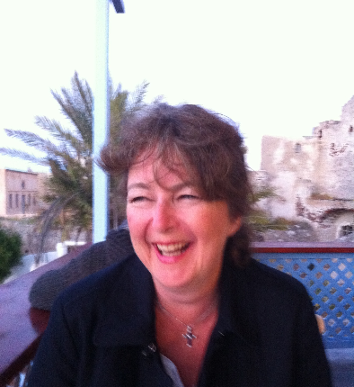 Elizabeth (Liz) Brierley

I am a lay member of the Church of England and have been a member of the Church of England throughout my life. I currently worship at St Bartholomew’s in Crewkerne, a church in the South Somerset Deanery.
Born in 1965 I was Christened that year and was confirmed at the age of 13 in Saint Bartholomew’s Church Crewkerne. At that time I lived in Haselbury Plucknett and was a regular attendee and bellringer at St Michael’s in the village. My church attendance was less regular over the next two decades until I joined the congregation of St Andrews in Preston near Weymouth in 2001.My faith has strengthened and developed over the last two decades.
I am now retired but spent most of my working life in business as a Chartered Accountant having qualified in 1992 and retired in March this year.
I am married to a retired Royal Navy helicopter pilot and we currently run a smallholding in a hamlet outside Crewkerne in Somerset.
My family moved to Somerset in 1974 and I was lucky enough to grow up in a thriving rural community, I went to Haselbury Plucknett Primary School, Maiden Beech Middle School, Wadham School Crewkerne and took my A Levels at Yeovil College. As an undergraduate, I studied Ancient History and Archaeology at Manchester University and have a real interest in the history and a love of England’s magnificent churches and cathedrals.
I am a trustee of two charities, and in the past 20 years have been a school governor of 3 different schools.
Currently I am the Trustee responsible for finance at Beyond the Streets, a Christian charity that works to see women energised by their future and not defined by their past. The Charity’s vision is of a society where everyone is able to live safe and independent lives, free from the structural inequalities and societal norms that compel women into selling sex. It’s mission is to raise awareness of the sex industry and survival sex, challenge the societal norms that perpetuate harm, and transform responses by providing direct support, shaping policy, and equipping others to take action.
I am also the finance trustee of a grant giving medical charity called the Dorset Health Trust and give practical help to the local branch of Riding for the Disabled which includes looking after one of their ponies for them.

Since returning to live near Crewkerne in 2020 I became involved with a small chapel in Hewish called the Church of the Good Shepherd and there I met CJ Davis, our excellent Rector. Attendees at the Church of the Good Shepherd were small in number and sadly have dwindled to nothing so my husband and I have become regular attendees at St Bartholomew’s and have found the spiritual leadership provided by CJ Davies to be truly inspirational. I therefore wanted to do more to help the Church and have served on the St Bartholomew’s PCC since April 2026.
I was unsure about standing for the General Synod because I felt that I did not know enough about it and that there would be more qualified and better informed candidates standing. However, I have heard that there are only four people standing for the five Bath and Wells places for lay members, so am offering my services as I feel that although my experience of CofE administration and organisation is rudimentary, I may have something to offer. If I am wrong on the numbers and there is a need for an election please do give your vote to the candidates with greater experience and more relevant skills.
If my skills in finance, people and business management are of use to the Church, I would gladly offer them up. I was a Partner in a firm of Chartered Accountants and worked with owner managed business throughout my career. The majority of my clients were farmers and rural businesses, and I have also acted for Charities. I now run a smallholding so can speak with some knowledge and experience about farming community. I was responsible for significant numbers of people and large budgets as a Partner (and business owner) and tried to manage my teams with fairness and balance, with a strong emphasis on training and personal development for all.
If I were to serve on the General Synod I would do so with enthusiasm and drive. Currently I would like to focus on the plight of rural parishes, and I am a supporter of the Save the Parish organisation. Funding for rural parishes is at a crisis point and furthermore it appears to me that the red tape that ministers have to deal with is so onerous that it causes stress and impacts upon their health and effectiveness. This is leading to a shortage of full-time clergy, and overwork for the willing but retired contingent.
In summary, I am keen to serve on the General Synod, I would do so energetically and would combine a strong faith with third sector and private sector experience, and hope that with God’s support and guidance I could be of value to the General Synod.

