

Leadership Safeguarding Pathway

Participant Workbook

Name _______________________

Parish / Context _______________________

Role _______________________

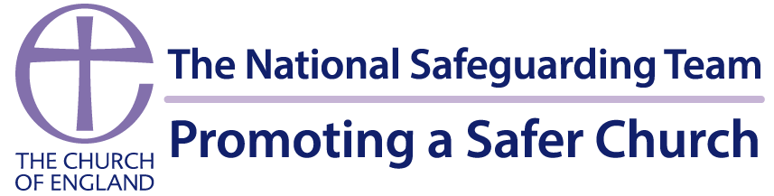

Version April 2026
Contents
1. Introduction 3
2. Learning Outcomes 3
3. Structure 4
Safety Guidelines 5
4. Pre-work ahead of Session 1 7
5. Pre-work for session 2 13
6. Consolidation and Evaluation 19
7. Further information/resources 22

1. Introduction

Welcome to the Leadership Safeguarding Pathway - a space designed to challenge, inspire, and strengthen how we lead. This training isn’t about ticking boxes or memorising procedures. It’s about shaping the kind of leadership that creates safety, models integrity, and builds a culture where people genuinely flourish.
Over the two sessions, we’ll explore what healthy culture looks like, how power and influence can be used well, and how leaders can prevent harm before it happens. We’ll look honestly at what can go wrong, learn from lived experience, and equip ourselves with the insight, confidence, and clarity needed to respond well when concerns arise.
The National Safeguarding Learning and Development Framework sets out the vision for making sure that all church officers develop an appropriate level of skills and knowledge in safeguarding.
National Safeguarding Learning and Development Framework 2024
https://www.churchofengland.org/sites/default/files/2026-01/safeguarding-learning-and-development-framework-2024-amended-7.1.pdf

2. Learning Outcomes

The learning outcomes are linked to the National Safeguarding Standards. This pathway offers the opportunity for the following outcomes to be achieved:
- Culture Leadership and Capacity – Examine how, as leaders and influencers within Christian communities, we can shape healthy culture, and effective leadership, resulting in best safeguarding practice.
- Prevention – Explore how safeguarding concerns and abuse can be prevented and how character, charisma, and influence, can shape the experiences of others in church.
- Assess and Manage Risk – Recognise when risk-assessment and risk-management processes are needed and understand when, why, and how they must be used.
- Victims and Survivors – Reflect on how abuse and trauma can affect people’s lives, relationships, and interactions with others in a community setting, leading to better responses to victims and survivors; and
- Learning, Supervision and Support – Assess and apply learning and use it to develop an individual action plan that will improve safeguarding practice and responses.

3. Structure

The Leadership Safeguarding Pathway is usually delivered online to small groups, though there may be opportunity for the learning to be delivered in-person.
The pathway consists of two sessions, each session is 90-minutes long, and the sessions are spaced a week apart, with an evaluation task after the final session. The evaluation asks you to reflect on the impact the pathway has had on your learning and how you have, or will, put the learning from this course into practice.
Pre-work is also given ahead of each session and is detailed within this workbook.
This learning pathway includes a range of activities:
  - Self-reflective, preparation tasks
  - Sections of input delivered via presentation.
  - Group participation activities.
  - A case studies to bring the material to life.
  - Additional optional activities and resources to further the learning.

Safety Guidelines

Anonymity & confidentiality
Participation and discussions within the sessions are private and confidential to the group. Any personal experience shared remains confidential to this group, unless there is a need to share information because someone is at risk.
Safety
There may be people with lived experience in the meeting, please be aware that we will be discussing issues of vital importance, which may trigger feelings and reactions from previous experiences. Please be gentle with each other and yourself. It is important to remember that there may be survivors in the group that have not disclosed their lived experience. Everyone is responsible for their own safety and participation: only share what you feel comfortable with. If you find something triggering it is ok to say so and to do whatever you need to keep safe. Take time out if you need to; please let someone know if you decide to leave early. Support is available if you have lived experience, you can speak with your Diocesan Safeguarding Team, or with Safe Spaces:
Safe Spaces is for anyone who has experienced Church-related abuse, of any type, in England or Wales. Safe Spaces has a team of support advocates who are specially trained in supporting survivors of sexual violence and have received additional training in how churches respond to abuse cases, the way in which faith and Church-related settings have been used to carry out abuse, and the issues affecting people who have had, or still have, a relationship with the Church. You can contact the Safe Spaces team using the following details.
Phone: 0300 303 1056
(answerphone available outside of opening times)
Email: safespaces@firstlight.org.uk
A live chat service is also available through the Safe Spaces website – Safe Spaces England and Wales – Home - Safe Spaces England and Wales
Opening times: Monday to Friday: 9am to 9pm, Saturdays: 9am to 1pm, Sundays: 1pm to 5pm
Home - Safe Spaces England and Wales
Participation
Your active participation is most welcome. We all bring valuable wisdom and experiences to share and learn from each other. We hope you will feel able to fully participate to get the most from the group. Please let us know if there is anything else we can do to support your participation and make this the best experience possible.

Inclusion and respect
We bring our diversity of experience and perspectives. Please help us to ensure that all voices can be heard. Let's disagree respectfully and kindly, and approach difference with curiosity rather than the need to be right. We are committed to being inclusive and anti-discriminatory. The Learning and Development Framework at pages 19 and 20 gives options for other ways to access the pathway if you have a disability or difficulty accessing the training, please speak to your Diocesan Safeguarding Team.

4. Pre-work ahead of Session 1
(approximately 1 hour)
Ahead of session one we ask that you complete the three tasks below:
- Watch one or two of the Diocese of Newcastle videos -
If I Told You, What Would You Do? - Newcastle Diocese
https://www.newcastle.anglican.org/if-i-told-you-what-would-you-do-/

Scroll down to the green boxes and select either ‘Would you make me feel safe’ or ‘Would you encourage me to use my voice’ (or both) where you can find the resources and videos. Come to the session prepared to discuss the impact of the videos and what you took from them.

(Permission to use the If I Told You What Would You Do resources has been given by the intellectual owners, Reverend John Villaseca and Reverend Rae Caro. The films were designed and written by Dr Sarah Troughton and David Creese, with supporting theological reflections by The Revd Canon Dr Rae Caro and The Revd John Vilaseca. Music written and performed by David Creese.)

- Consider the Culture Cube - this is not a repeat of the last course! Please come to the session prepared to reflect in the group an example of good practice and an example where things could be done differently or better for each area from your context. The next page has a template for you to complete to do this.

- Power and Influence Self-Assessment - consider the different types of power, how they relate to ministry, and your own use of power and influence through a self-assessment document which is based upon French and Raven’s bases of power, this document follows below the culture cube template. You will not be asked to share your scores during the session. There is no set word count for your reflections.

Send your workbook with the completed Culture Cube, Self-Assessment, and reflections to training.safeguarding@bathwells.anglican.org no less than one week prior to Session One.

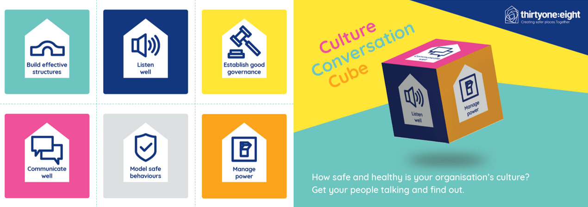  Think about the structures, reporting lines and accountability within your context. | Think about the stories that are being told about your context. | Think about the way your context is controlled and governed. | Think about the formal and informal power structures within your context. | Think about how your context communicates internally and externally. | Think about the everyday activities and behaviours that are accepted within your context.
Good Practice | Good Practice | Good Practice | Good Practice | Good Practice | Good Practice
Area for improvement | Area for improvement | Area for improvement | Area for improvement | Area for improvement | Area for improvement

Power and Influence Self-Assessment (Based on French & Raven’s Six Bases of Power)

It is important to remember that everyone in a position of responsibility and/or leadership carries some form of power and influence.

Instructions:
For each statement, rate yourself from 1 - 5:
1 – Rarely true of me
2 – Sometimes true
3 – Occasionally true
4 – Often true
5 – Very true of me
Then reflect on the questions that follow each power category.

1. Legitimate Power or Influence – comes from your recognised role, position, or responsibilities.
Statement | 1 |  |  | 2 |  | 3 |  |  | 4 |  |  | 5 |  |  | Reflection Prompts
People usually look to me for directions because of my role. |  |  |  |  |  |  |  |  |  |  |  |  |  |  | - How do I ensure I use positional authority with humility?  - Do I ever rely too much on my role rather than relationship?
I feel confident exercising authority when it is appropriate.
I communicate my responsibilities clearly, so others understand my remit.
Space for reflection

2. Reward Power or Influence - ability to recognise, encourage, or reward supportive behaviour.
Statement | 1 |  |  | 2 |  | 3 |  |  | 4 |  |  | 5 |  |  | Reflection Prompts
I intentionally praise or affirm others for their contributions. |  |  |  |  |  |  |  |  |  |  |  |  |  |  | - Do I use encouragement to build up the Body of Christ?  - Are my rewards (formal or informal) fair, transparent, and generous-spirited?
I help people feel valued and appreciated in their ministry.
I can influence others by highlighting positive outcomes or benefits.
Space for reflection

3. Coercive Power or Influence - able to set boundaries or apply consequences when necessary.
Statement |  |  | 1 |  | 2 |  | 3 |  |  | 4 |  |  | 5 |  |  | Reflection Prompts
I set clear expectations and follow through when commitments are not met. |  |  |  |  |  |  |  |  |  |  |  |  |  |  |  | - Do I use corrective power sparingly and pastorally?  - How can I ensure discipline is rooted in safeguarding, justice, and compassion?
I feel able to challenge unhelpful or unsafe behaviour.
I use consequences proportionately and with pastoral care.
Space for reflection

4. Expert Power of Influence - comes from knowledge, skills, or experience.
Statement |  |  | 1 |  | 2 |  | 3 |  |  | 4 |  |  | 5 |  |  | Reflection Prompts
People seek my advice because of what I know or have lived through. |  |  |  |  |  |  |  |  |  |  |  |  |  |  |  | - Do I use my expertise to empower others rather than elevate myself?  - How am I modelling lifelong learning?
I keep developing my skills to serve more effectively.
I share my knowledge generously rather than protecting it.
Space for reflection

5. Referent Power or Influence - comes from trust, respect, and relationships.
Statement |  |  | 1 |  | 2 |  | 3 |  |  | 4 |  |  | 5 |  |  | Reflection Prompts
People feel comfortable approaching me and confiding in me. |  |  |  |  |  |  |  |  |  |  |  |  |  |  |  | - How does my character reflect Christ-like leadership?  - Do I cultivate trust in healthy, transparent ways?
I try to lead by example in integrity and discipleship.
I intentionally build relationships based on kindness and respect.
Space for reflection

6. Informational Power or Influence - ability to influence through sharing/controlling information.
Statement |  | 1 |  |  | 2 |  |  | 3 |  |  | 4 |  |  | 5 |  |  | Reflection Prompts
I communicate information clearly and transparently. |  |  |  |  |  |  |  |  |  |  |  |  |  |  |  |  | - Do I steward information ethically and safely?  - How do I balance transparency with confidentiality, especially in safeguarding contexts?
I use information to support good decision-making.
I avoid withholding information in ways that could create confusion or mistrust.
Space for reflection

Scoring and Interpretation
You can total each section (max 15) or look simply at patterns.
- High scores (11–15):
You use this form of power of influence regularly.
Consider: Is it used for service, empowerment, and wellbeing?
- Medium scores (7–10):
This is a moderate part of your leadership.
Consider: Is there room to develop or balance your approach?
- Low scores (3–6):
You may use this power or influence type less often.
Consider: Would strengthening it improve your ministry? Or is it appropriate to your context?

Closing Reflection Questions
- Which type of power or influence do I rely on most?
- Which type might I need to grow in for healthier leadership?
- How do these power or influence dynamics align with servant leadership and Anglican values?
- How can I use power or influence in ways that promote safety, dignity, and flourishing for all?
Space for reflection

5. Pre-work for session 2
(approximately 45 minutes, 1 hour 15 minutes if the optional activity is completed)

Ahead of session two we ask that you complete the three tasks below:
- Read the summary provided below of the case of Mike Pilavachi and Soul Survivor which sets the scene for the case study activity within the session.

OPTIONAL - Let There Be Light, is offered as an optional additional preparation activity, the video is 31 minutes long.

Let There Be Light

https://www.youtube.com/watch?v=YVZkgdt32u8

Reflect on what was discussed in session 1 - responding well to those with lived experience, healthy culture, managing safeguarding information, relationship dynamics and power and consider how you can take this forward in your own role by answering the question below:
How might your natural leadership style help or hinder the development of healthy cultures?

You may wish to draw on your responses to the Power and Influence Self-Assessment or other frameworks you are already familiar with.
You do not need to submit any written work prior to session 2.
Mike Pilavachi and Soul Survivor

Background Context
Mike Pilavachi, the founder of Soul Survivor and a prominent figure in UK evangelical circles, was investigated by the Church of England following numerous allegations of abusive behaviour. In 2023, an independent safeguarding report by Fiona Scolding QC confirmed that his conduct over several decades was abusive.
Soul Survivor was founded by Mike Pilavachi in 1993. It started within St Andrew’s Church, Chorleywood, and was later based at Soul Survivor Watford, a Church of England congregation. It’s leadership structure included senior pastors, youth leaders, worship leaders, and administrative staff.
Soul Survivor was registered as a UK charity (non-profit) under the Charity Commission and was run by a board of trustees responsible for financial and legal oversight.
Activities included large annual festivals, discipleship schools, worship leadership courses, and church planting support. Soul Survivor also produced music albums, books, and teaching materials.
Soul Survivor operated under Anglican oversight from the Church of England and partnered with Christian youth ministries across the UK and internationally.

Patterns of Abuse
Mike Pilavachi abused the power he held by exploiting his role as a trusted spiritual leader, knowing that those around him respected or idolised him. The Scolding Review highlighted a long-term pattern of coercive and abusive behaviour masked as pastoral care or spiritual mentoring. Mike Pilavachi’s abuse can be described as follows:
- Psychological/Emotional/Spiritual abuse:
- Manipulative use of religious authority to control and manipulate young people.
- Positioning himself as a spiritual father and pressuring young men to submit to his authority under the guise of discipleship.
- Creating a culture of fear and obedience where questioning or challenging his authority was discouraged or punished.
- Control and Isolation: Isolating individuals from other sources of support or leadership, effectively monopolizing their spiritual and personal development.
- Expecting total loyalty and often demanding secrecy or silence about his methods and conduct.
- Emotional manipulation: Using charismatic influence to draw people into unhealthy levels of dependence. Grooming behaviour, including favouring certain young men and creating exclusive relationships that caused jealousy or emotional distress among others. Making people feel special or chosen and then withdrawing affection or attention as a form of punishment or control.
- Physical abuse:
- Engaging in prolonged full body massages with young men in private, often alone.
- Wrestling session which he claimed were bonding experiences but which the victims reported as invasive and uncomfortable.
- These activities were often framed as spiritual or mentoring experiences blurring boundaries.

Victim Impact
The victim impact of the Soul Survivor case has been profound and long lasting, affecting survivors’ emotional, spiritual, psychological and social wellbeing. Survivors came forward with deep personal stories detailing the damage caused both by Pilavachi’ s behaviour and the institutional failures that enabled it.
- Psychological and Emotional Trauma:
- Survivors report long term effects including anxiety, depression, PTSD and complex trauma.
- Many experienced confusion, shame, and guilt, particularly because the abuse was framed as ‘discipleship’ or spiritual mentoring.
- Some said they felt “broken”, “used”, or “manipulated”, often not realising until years later that what they experienced was abusive.
- “He made me feel chosen, then discarded. It messed with my head for years”.
- Spiritual Abuse and Crisis of Faith:
- Survivors describe a deep spiritual betrayal – their abuser was seen as a mentor, a father figure, even a conduit to God.
- Many experienced a crisis of faith, struggling to separate their view of God from their experience of Pilavachi’ s control.
- Some left the Church entirely, unable to reconcile their experience with a faith that promised safety and truth.
- “He used God to control me. It took years before I could even pray again”.
- Loss of Community and Belonging
- Many survivors were part of a tight-knit Christian communities centred on Soul Survivor. When they spoke out, they were often ostracized or disbelieved.
- Some lost friendships, support systems and ministry opportunities.
- Victims reported feeling isolated when they realised others in leadership knew or suspected what was going on and said nothing.

- Professional and Vocational Harm:
- Some young men were mentored for leadership roles, only to have their careers manipulated or derailed when they distanced themselves or raised concerns.
- Allegations of emotional blackmail – e.g. if someone pulled away from Mike’s mentorship, they were sidelined in ministry.
- “I was told I wasn’t ‘spiritually mature enough’ anymore – just because I didn’t want to do the massage thing”.
- Delayed Recognition of Abuse
- Because the behaviour was framed as spiritually legitimate, many victims only later realised it was abusive.
- This delay in recognition led to a longer healing process, often with self-blame and difficulty trusting others or institutions.
- Retraumatisation During the Investigation:
- Victims have said the Church of England’s safeguarding process was often retraumatising citing poor communication, lack of pastoral support, and having to retell their stories multiple times.
- Some said they felt used again, this time by a system that promised justice but delivered delay and emotional turmoil.
- Public acknowledgement of the abuse and an apology were issued in 2023 which was welcomed but felt like it was too little too late.

Institutional Failures
The Soul Survivor case involving Mike Pilavachi revealed serious institutional failures within the organisation and the wider Church of England. These failures allowed abusive behaviour to go unchecked for decades, despite warning signs and complaints.
The Scolding Review identified serious safeguarding failures:
❗ Poor Safeguarding Oversight
No monitoring of Mike’s mentoring practices or personal interactions.
❗ Complaints Ignored
Concerns over decades were dismissed or minimised.
❗ Culture of Silence
Staff and volunteers feared consequences for speaking out.
❗ Lack of Accountability
Leadership structures centred too much around one charismatic figure.
❗ Protection of Reputation
Institutional image was prioritised over people’s safety.

Key Lessons for Faith Leaders
✅ Safeguarding Applies to Everyone
No leader is exempt from boundaries, however gifted or respected.
✅ Healthy Leadership Requires Accountability
Ensure:
- External oversight
- Transparent decision-making
- Clear supervision structures
✅ Avoid Isolated or Private Ministry
- Never meet in ways that reduce visibility or accountability
- No private physical contact
- Pastoral work should be open and observable
✅ Listen to Concerns Early
Create a culture where:
- People can question leadership
- Safeguarding worries are welcomed, not feared
✅ Watch for “Special” Relationships
Avoid:
- Favouritism
- Secrecy
- Emotional dependence
- Exclusive mentoring arrangements
✅ Build a Safe Ministry Culture
A healthy church culture is:
- Humble
- Transparent
- Accountable
- Survivor-focused
Safeguarding is part of discipleship. Accountability is part of leadership. Healthy power reflects Christ.

Chronology of events
Date | Event
7 March 1958 | Michael (Mike) Pilavachi was born in London, of Greek Cypriot heritage.
1974 | Mr. Pilavachi became a Christian following a conversion experience at age 16.
1987 | Mr. Pilavachi became a full-time youth minister at St Andrew’s, Chorleywood, aged 29.
1993 | Mr. Pilavachi founded the Soul Survivor summer festivals.
1993 | Soul Survivor Church began, emerging from St Andrew’s Chorleywood (Church of England).
2004 | Safeguarding concerns relating to Mr. Pilavachi’ s behaviour were raised with him and the Chair of Trustees.
2005–2006 | Mr. Pilavachi met with the Chair of Trustees and asked whether he should stop “horseplay and rough and tumble”. He was advised to stop.
2008 | Mr. Pilavachi later stated that David Westlake (Trustee) advised him to stop giving massages.
2012 | Mr. Pilavachi was ordained as a Deacon in the Church of England.
2013 | Mr. Pilavachi was ordained as a Priest in the Church of England.
2014 | Soul Survivor Church became subject to a Bishop’s Mission Order (BMO).
2016 | Mr. Pilavachi was made an Honorary Canon of St Albans Cathedral.
2016 | An allegation was made that Mr. Pilavachi touched a man in a sexualised way while giving a massage.
2019 | The Soul Survivor summer festivals came to an end.
2020 (New Year Honours) | Mr. Pilavachi was appointed MBE for services to young people.
July 2020 | Mr. Pilavachi received the Archbishop of Canterbury’s Alphege Award for Evangelism and Witness.
Early 2023 | Allegations relating to Mr. Pilavachi were reported in the press.
April 2023 | Mr. Pilavachi stepped back from ministry roles and subsequently resigned from positions connected with Soul Survivor.
2023 | An internal safeguarding investigation into Mr. Pilavachi and others was carried out by the Church of England National Safeguarding Team and the Diocese of St Albans.
November 2023 | The Trustees of Soul Survivor commissioned an Independent Review into the culture, leadership, and safeguarding practice.

6. Consolidation and Evaluation

In evaluating this training what really matters is whether the “learning experience” has affected your beliefs, values and understanding at a deep level so that you are sufficiently prepared to engage in this work. We want to know that you now do things not because you must do them, but because you really want to exhibit those behaviours. This is called “second order” change – when people do things because there is an inner motivation.
So, if this “learning experience” has been effective, you will, in some respects, be a different person from the one that started the experience. The purpose of the evaluation, then, is to try to find out if any difference has indeed been achieved and whether after completing this training, you feel that you have been sufficiently prepared for the role you are undertaking.
At the beginning we set out the learning outcomes the programme is designed to deliver, and they are repeated here.
The learning outcomes are linked to the National Safeguarding Standards. This pathway offers the opportunity for the following outcomes to be achieved:
- Culture Leadership and Capacity – Examine how, as leaders and influencers within Christian communities, we can shape healthy culture, and effective leadership, resulting in best safeguarding practice.
- Prevention – Explore how safeguarding concerns and abuse can be prevented and how character, charisma, and influence can shape the experiences of others in church.
- Assess and Manage Risk – Recognise when risk-assessment and risk-management processes are needed and understand when, why, and how they must be used.
- Victims and Survivors – Reflect on how abuse and trauma can affect people’s lives, relationships, and interactions with others in a community setting, leading to better responses to victims and survivors; and
- Learning, Supervision and Support – Assess and apply learning and use it to develop an individual action plan that will improve safeguarding practice and responses.

The evaluation task
Reflecting on the preparatory tasks that you have completed, and the discussions from the two sessions of the pathway, complete the self-reflection and action plan below which asks you to identify what impact this pathway has had on your learning and what you can practically do to take this learning forwards within your own context.
The evaluation task should be submitted to training.safeguarding@bathwells.anglican.org within six weeks of completing session two.

Reflection and Action Points
Reflection and Action Points
Reflect:

What role do I play as a leader in my context in enhancing the safeguarding culture?

How has learning from this pathway impacted on how you see your role as a leader?

Action Plan
Developing a 4–6-month action plan will allow you to implement new and observable leadership behaviours which deliver concrete safeguarding outcomes and demonstrate that safeguarding is increasingly intuitive and at the heart of everything you do.
When developing this action plan consider how you would demonstrate the learning gained to:
- Shape a healthy culture, effective leadership and safeguarding for all
- Promote healthy cultures in your area of responsibility through your behaviours, using your influence positively
- Embed safeguarding principles in your beliefs and values
- Support others in their understanding and practice of safeguarding
- Demonstrate reflection on their practice or experiences of safeguarding

When creating your action plan think “SMART”
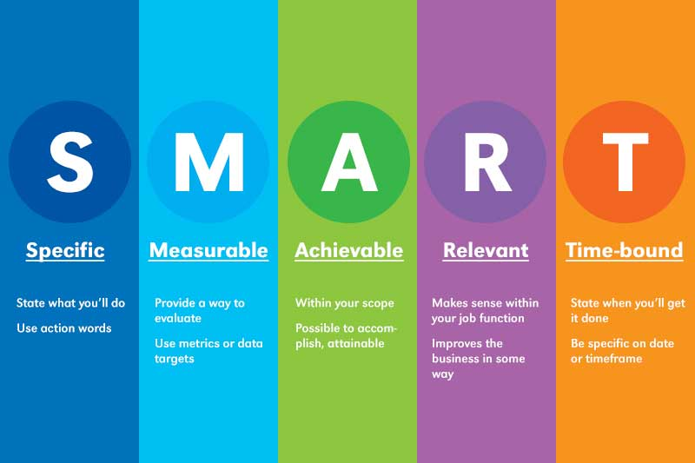
We would suggest that you develop 3-4 objectives for the next 6-8 months.
Objective  What would you link to achieve/ implement | Task/s  What do you need to do | Success Criteria  What will it look like if you achieve your objective | Timescale  When would you like to achieve this
Create an environment in which Safeguarding is not feared but spoken about openly, beyond process and policy | Safeguarding is discussed at PCC beyond reporting. | Discussions surrounding safeguarding in PCC’s are not a tick box but an open dialogue, in which we can explore how to create a safe space | 6 months

7. Further information/resources

These resources have been highlighted by a variety of people as being helpful for thinking about some aspects linked to safeguarding, some may be referenced in the sessions.
Please be aware that they can be challenging and may contain triggers so please do look after yourself and seek the help and support that is right for you.
If you are aware of other resources that would be useful to share, please contact Louise Warner Louise.Warner@LeicesterCofE.org .

The links below are to Googledocs, to help make it easier to find the resources that are of interest and always give you access to the most up-to-date resource list. You can access the resource lists without needing a Google account.
If needed you can download a document by clicking File, then Download and select a file format that works for you, or you can email it to yourself. You can also use Edit, Select All then Copy and paste. You do not need to request Edit Access.

Links to the resources
Books: Safeguarding Related Books.docx - Google Docs
Mixed Media: Mixed Media Safeguarding Linked Resources.docx - Google Docs
Reports and Reviews: Reports and Reviews Safeguarding Linked.docx - Google Docs

Church of England
Safeguarding e-manual | Safeguarding e-manual | The Church of England  https://www.churchofengland.org/safeguarding/safeguarding-e-manual
Parish Safeguarding Toolkit | Parish Safeguarding Resources | The Church of England  https://www.churchofengland.org/safeguarding/safeguarding-e-manual/parish-safeguarding-resources
Guidelines for the Professional Conduct of Clergy | The Guidelines | The Church of England  https://www.churchofengland.org/resources/clergy-resources/guidelines-professional-conduct-clergy/guidelines
National Safeguarding Standards | National Safeguarding Standards | The Church of England  https://www.churchofengland.org/safeguarding/national-safeguarding-standards

Helplines for further support
- Safe Spaces
Safe Spaces is for anyone who feels they have experienced church related abuse of any form in England or Wales. Safe Spaces comprises a team of trained support advocates who have undergone specialist training in supporting survivors of sexual violence and who have received additional specific training in how the churches respond to abuse cases, the way in which faith and church-related settings have been used to carry out abuse, and the issues affecting people who have had or still have, a relationship with the church.
You can contact the Safe Spaces team by: -
Tel: 0300 303 1056
(Answerphone available outside of opening times)
Email: safespaces@firstlight.org.uk
A live chat service is also available through the Safe Spaces website - Safe Spaces England and Wales – Safe Spaces England and Wales
The Safe Spaces team are available through their helpline and live chat service on:
Opening Times: Monday - Friday: 9am-9pm Saturday: 9am-1pm Sunday: 1pm-5pm

- NSPCC - For adults concerned about a child 0808 800 5000
- ChildLine - For children and young people on 0800 1111
- Action on Elder Abuse helpline 0808 808 8141
- 24-hour National Domestic Violence Helpline 0808 2000 247
- NAPAC – Offer support and advice to adult survivors of childhood abuse 0808 801 0331
- Stop It Now – preventing child sexual abuse 0808 1000 900
- Cruse – bereavement helpline 0808 808 1677

Websites
www.nspcc.org.uk (National Society for the prevention of cruelty to children)
www.womensaid.org.uk (Female domestic abuse charity)
www.restoredrelationships.org (Christian domestic abuse charity)
www.mankind.org.uk (Male domestic abuse charity)
www.stopitnow.org.uk (child safeguarding organization)
www.scie.org.uk (Social Care Institute for Excellence)
www.ceop.police.uk (child exploitation and online protection command)
www.wearehourglass.org (adult safeguarding charity)
www.ageuk.org.uk (adult safeguarding charity)
www.barnardos.org.uk (child protection charity)
www.theclewerinitiative.org (modern slavery charity)
www.modernslavery.co.uk (modern slavery charity)
www.macsas.org.uk (survivor advocacy charity)
https://houseofsurvivors.org/
https://survivingchurch.org/

